

Observational Report LAB 5: FIRewall exploration lab

ACS 545| Cryptography and Network Security

February 21, 2024

Ashutosh Mishra

Professor: ZesHeng Chen

* Observation Criteria: -

Note: -

1. Used Ubuntu Seed (v20.04 Focal) on Google Cloud Platform
2. Used Real VNC Viewer to perform the actions on GUI
3. All actions are being performed under username - **seed**

* Environment Setup: -

A folder named Crypto was created and the Labsetup file was downloaded from the Seed Documentation site. Post unzipping the folder we find a docker-compose.yml file which contains the configurations for three machines that are connected to the same LAN. The three machines are: -

1. seed-router
2. host1 (192.168.60.5)
3. host2 (192.168.60.6)
4. host3 (192.168.60.7)
5. hostA (10.9.0.5)

To create the three containers using the .yml file, firstly one can use either **docker-compose build** or **dcbuild** (alias).

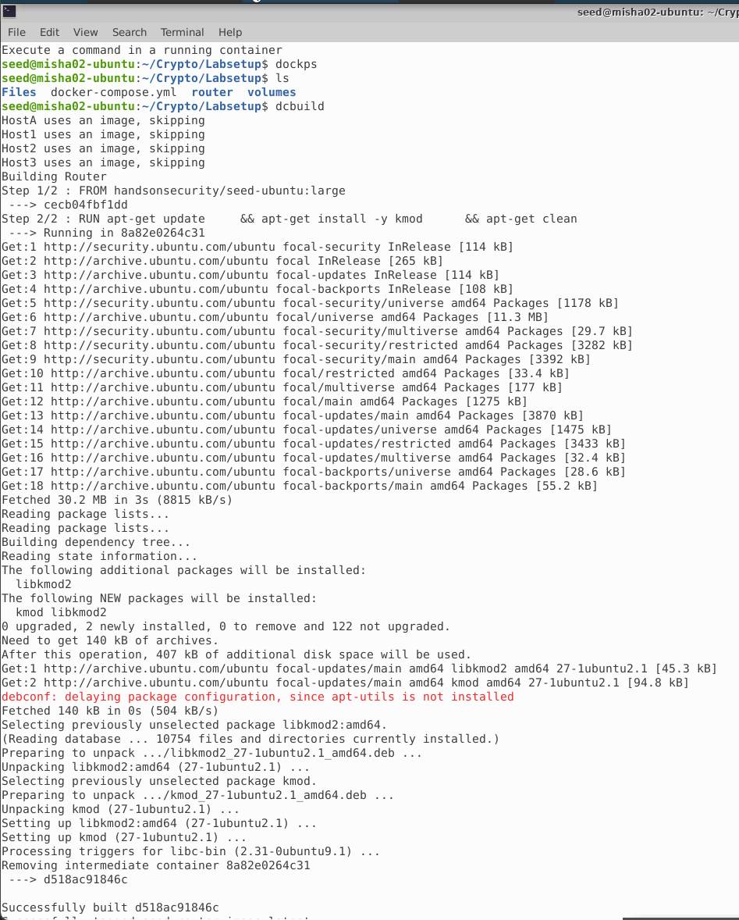

Now we will use either the **docker-compose up** or **dcup** (alias) to start the containers.

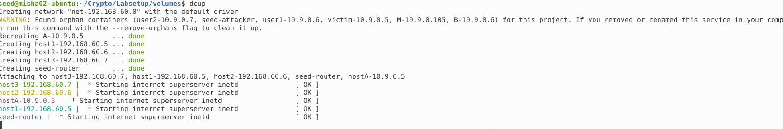

Now, as per the above screenshot, we can see that the containers are up. However, just to cross check we can use either **docker ps –format “{{.ID}} {{.Names}}”** or **dockps** (alias) to show the status of the containers.

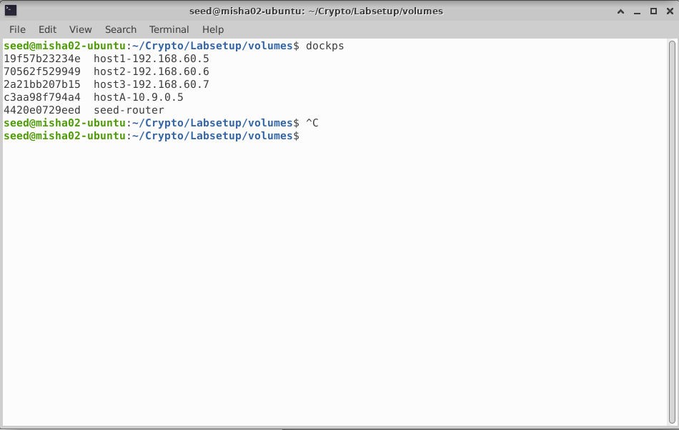

* Task 1 (Implementing a Simple Firewall): -
  + Task 1 A (Implement a Simple Kernel Module): -

For the first task, I have referenced the code from seedLabs site. The requirement is to refer to the same steps mentioned in the handout. Firstly, the code file is as below:-

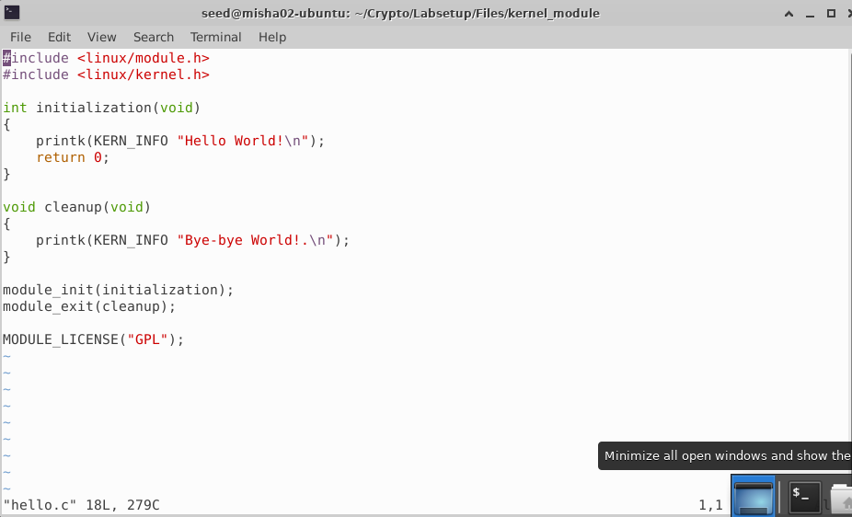

Now let’s have a look at the make file.

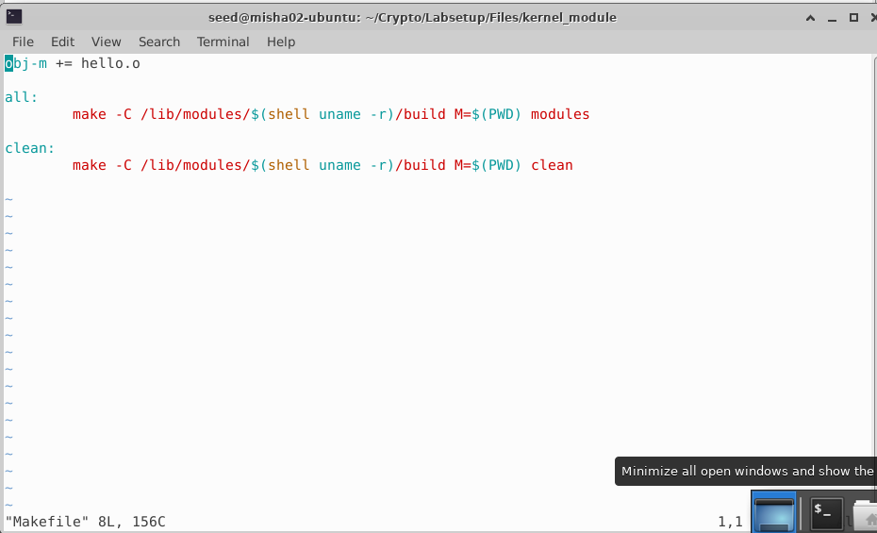

The very first step for this lab is to run make and see the files created.

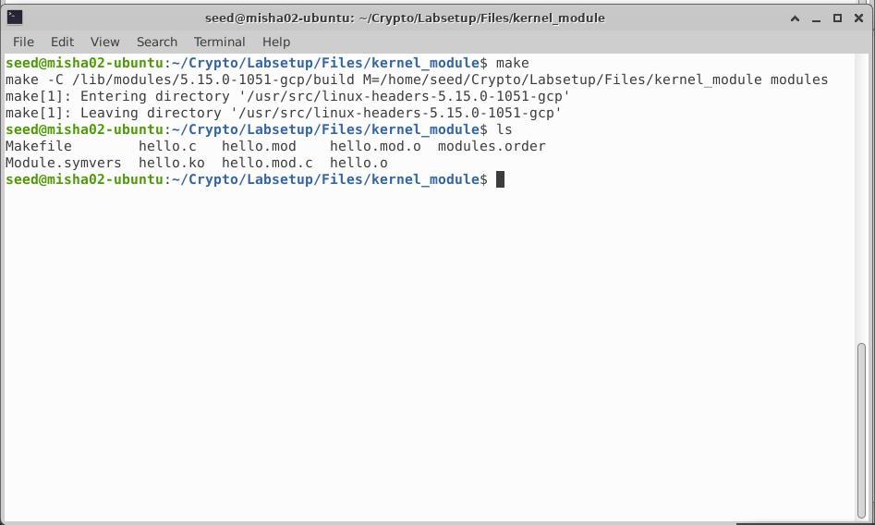

Now let’s insert module

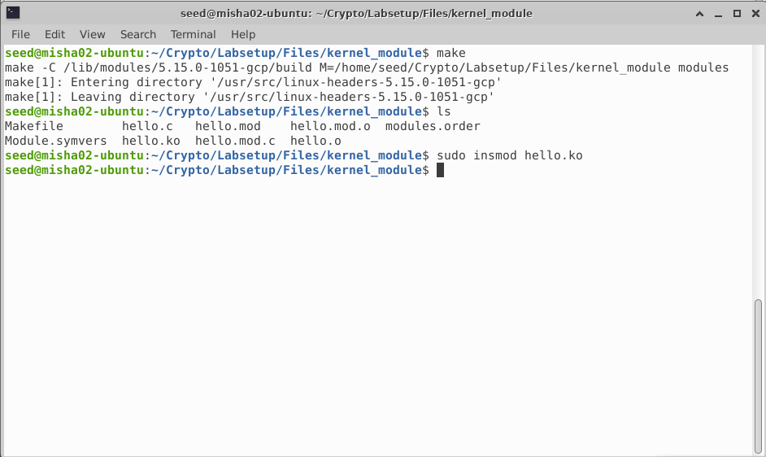

Listing modules and only hello mod

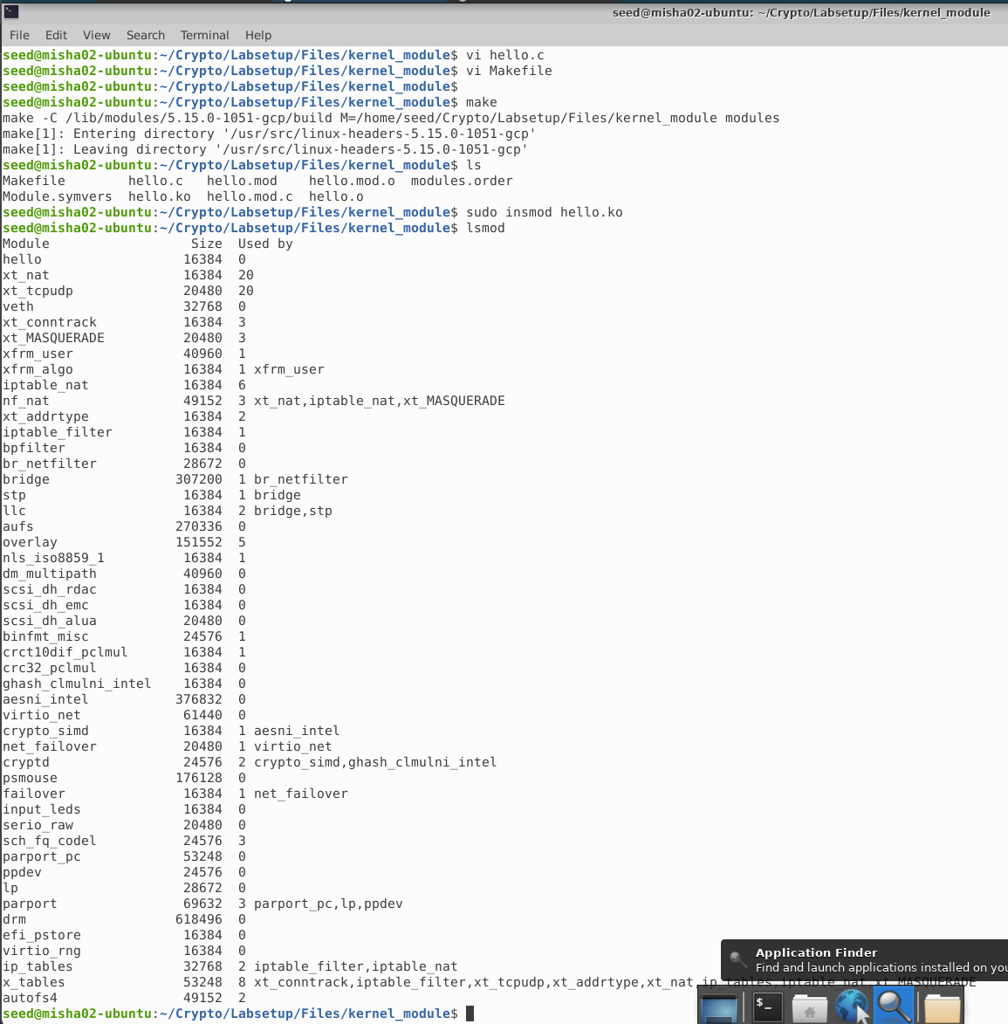

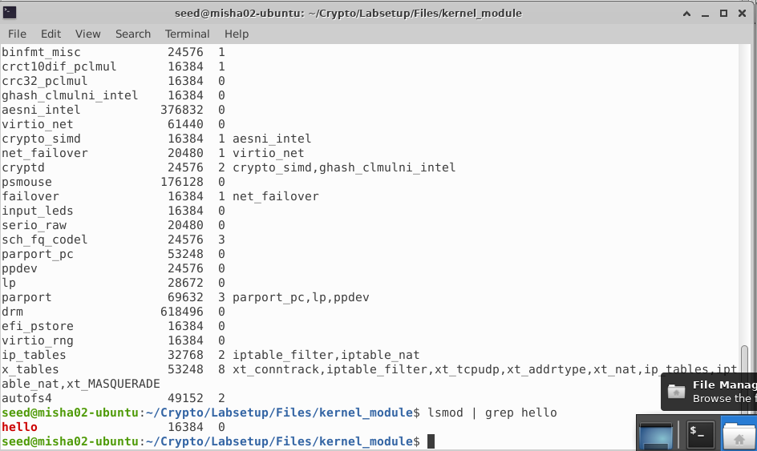

Now let's remove the module

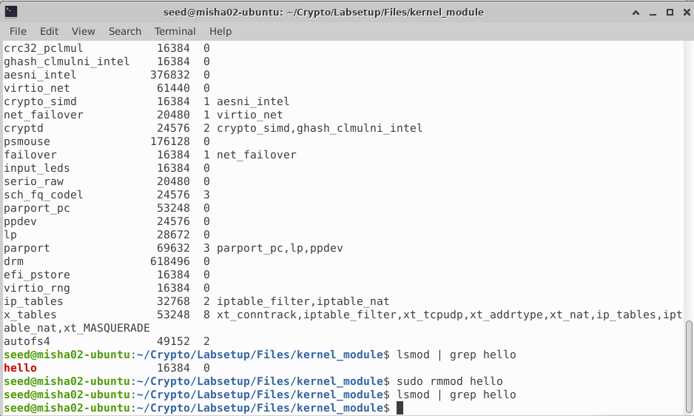

Finally let’s look at the message

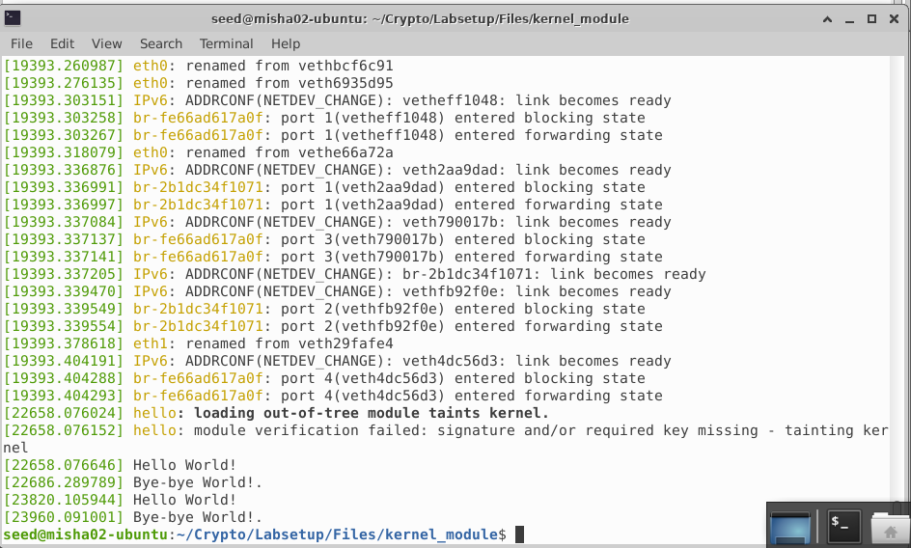

**Note: There are two instances of Hello World! and Bye-bye World! as I ran the steps twice.**

* + Task 1 B (Implement a Simple Firewall using Netfilter): -

For part B task, I have reused the same C code provided in the LabSetup file.

1. The first task is simple. We only need to change the ip in the file to 8.8.4.4. The code is as shown below.

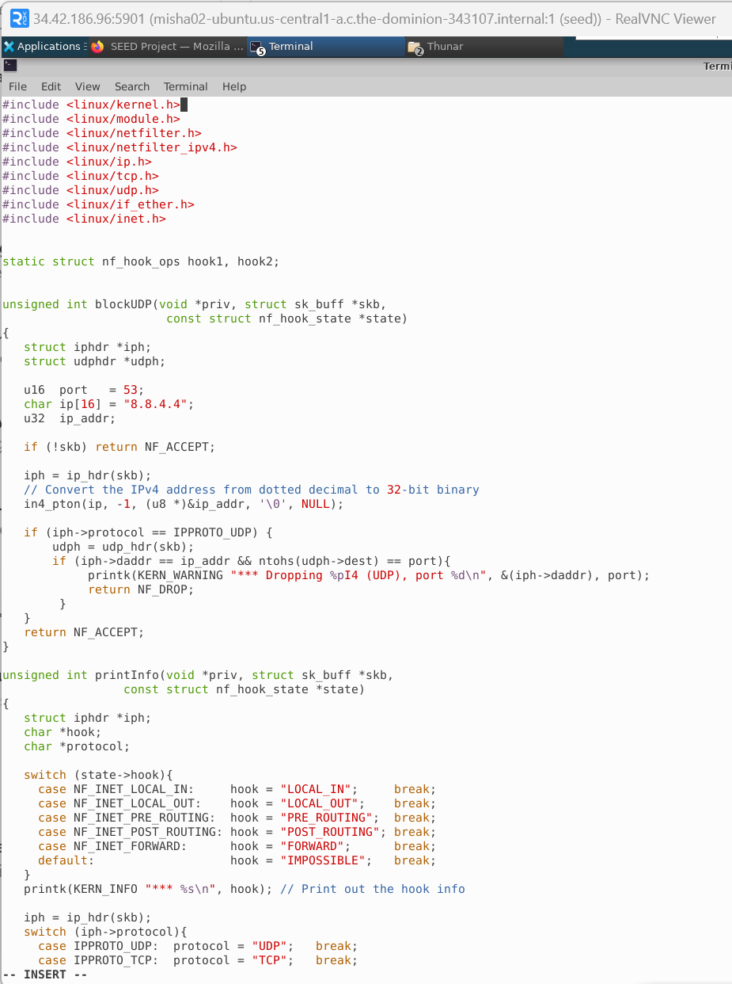

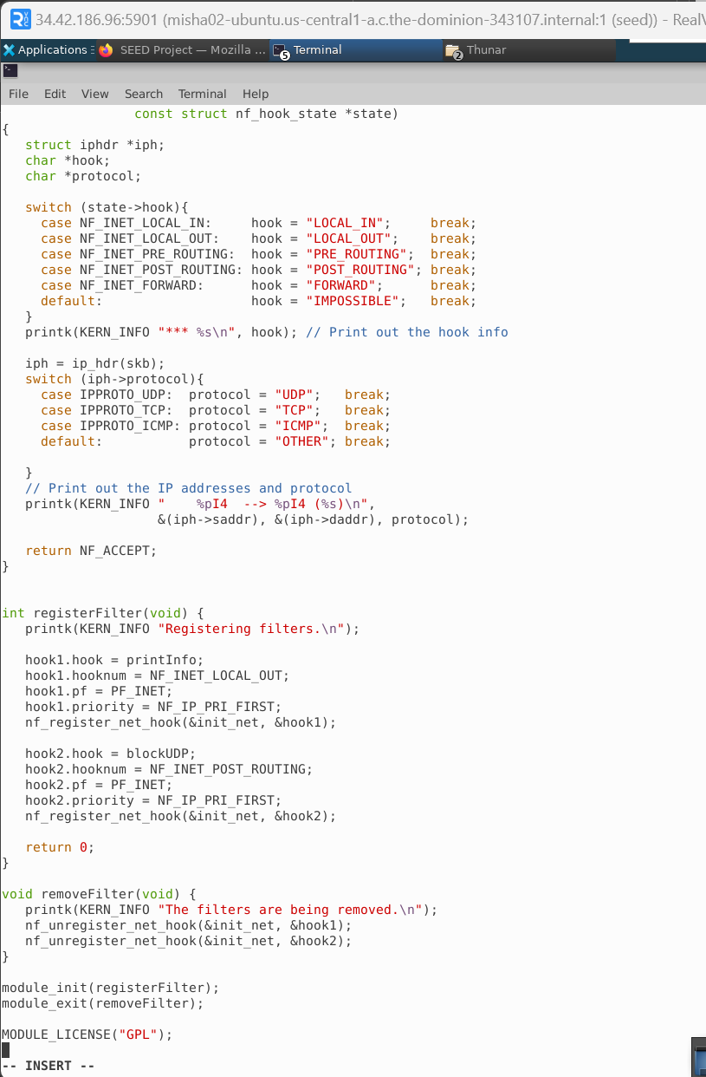

Now let’s test using dig if 8.8.4.4 is reachable. As we can see that it is.

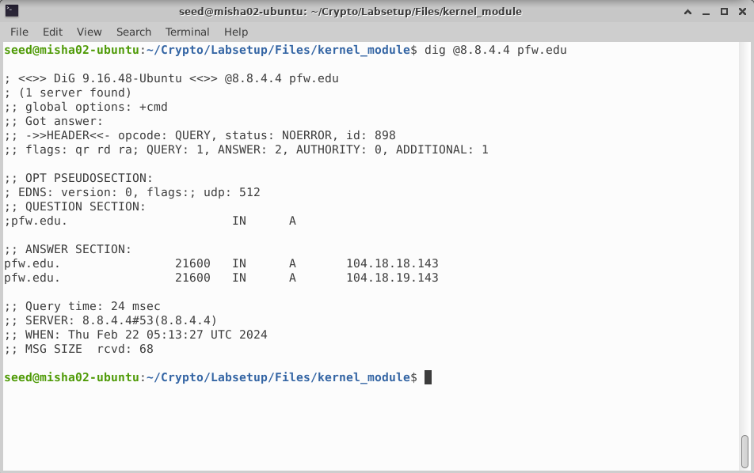

Now let’s use make to compile the code.

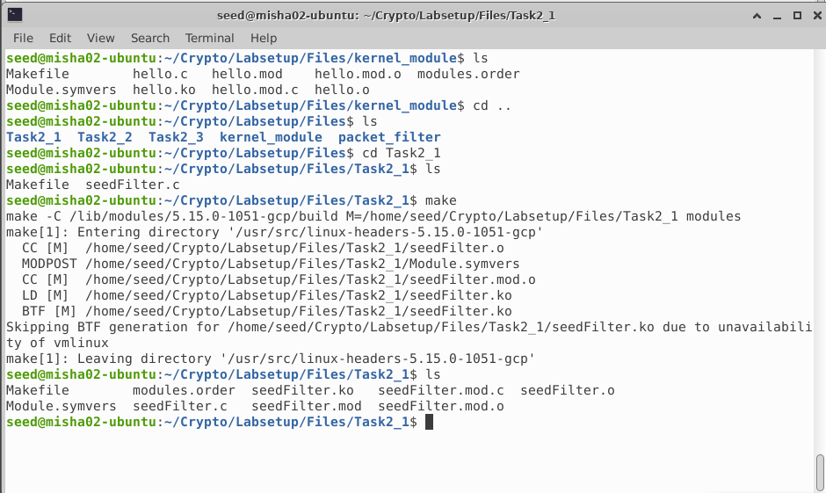

Now let’s install module.

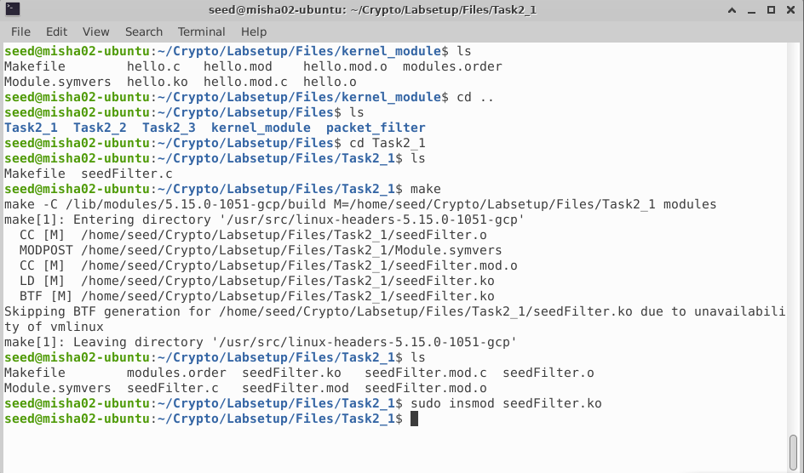

Let’s check if module is correctly installed.

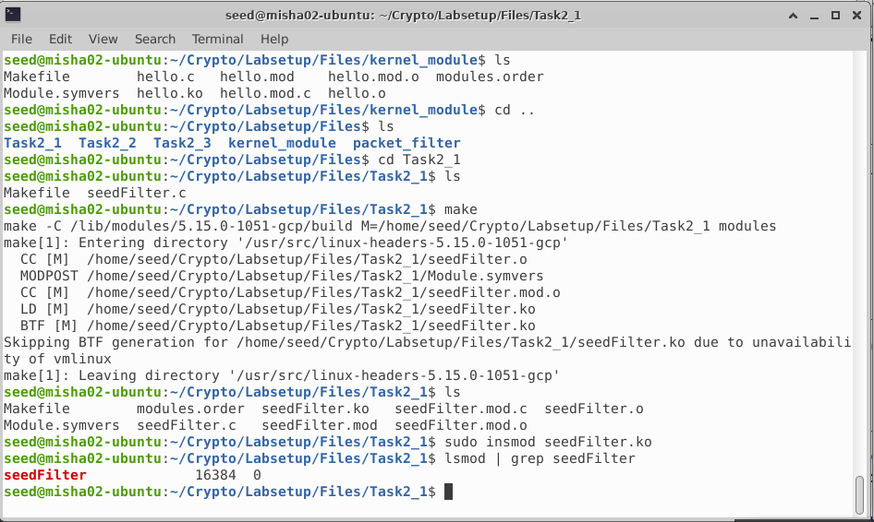

As we can see from above screenshot, it was successful.

Let’s try using dig to see if packet can be sent.

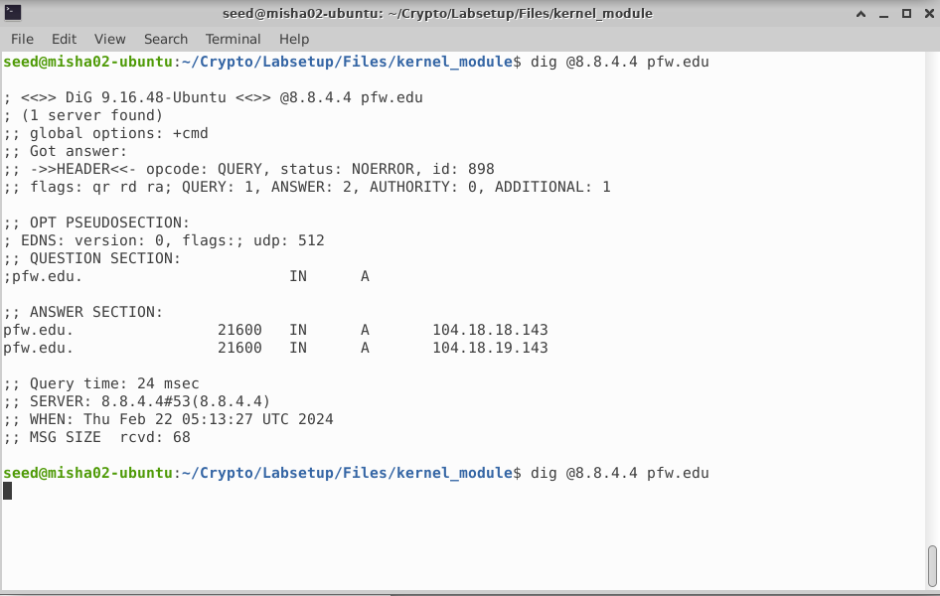

The execution takes some time and throws timeout error. Hence, the attack was successful.

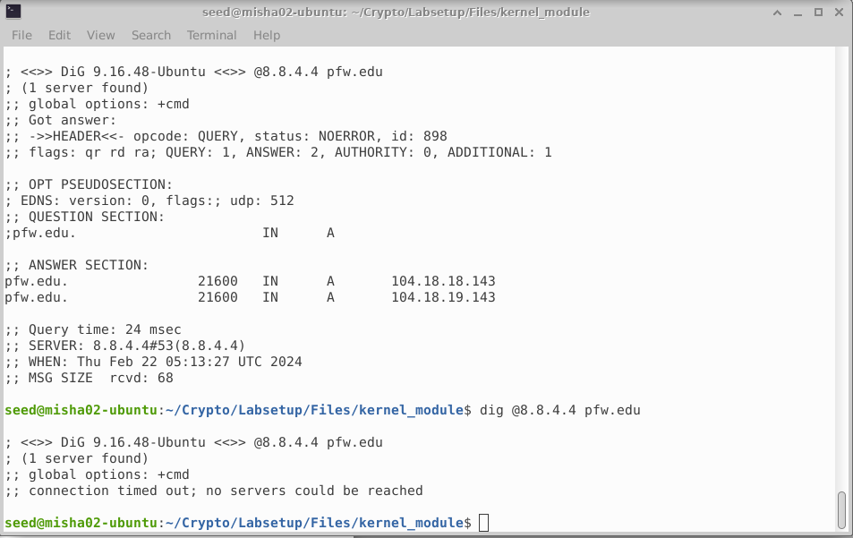

Let’s uninstall the module and recheck.

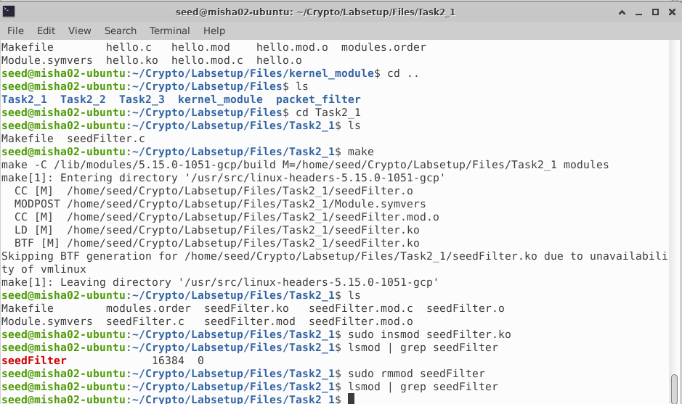

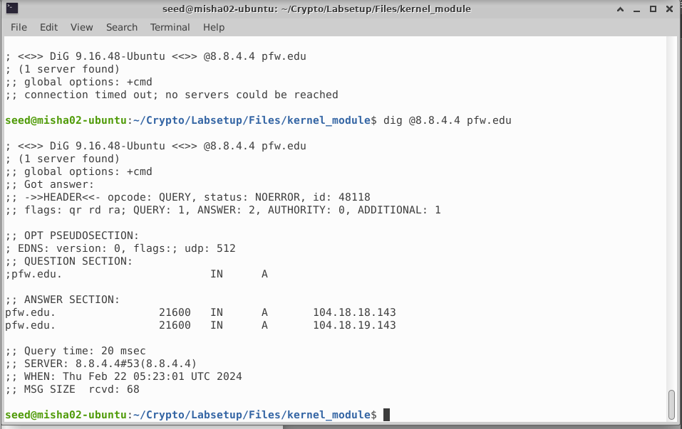

The task was completed successfully.

1. The second sub part requires us to use the printInfo function to all of the netfilter hooks. The code changes are as follows.

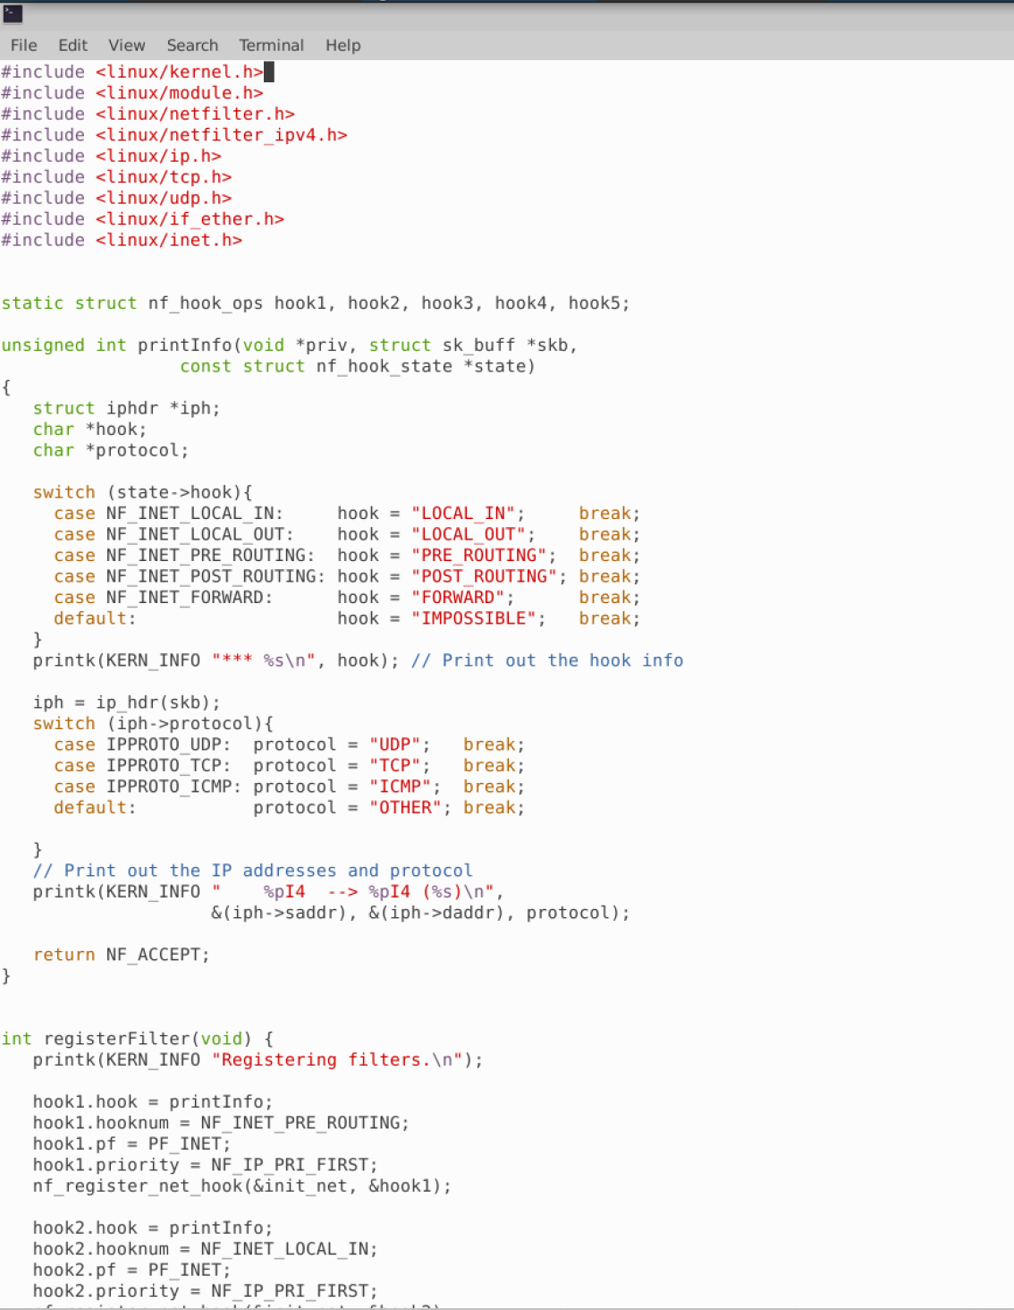

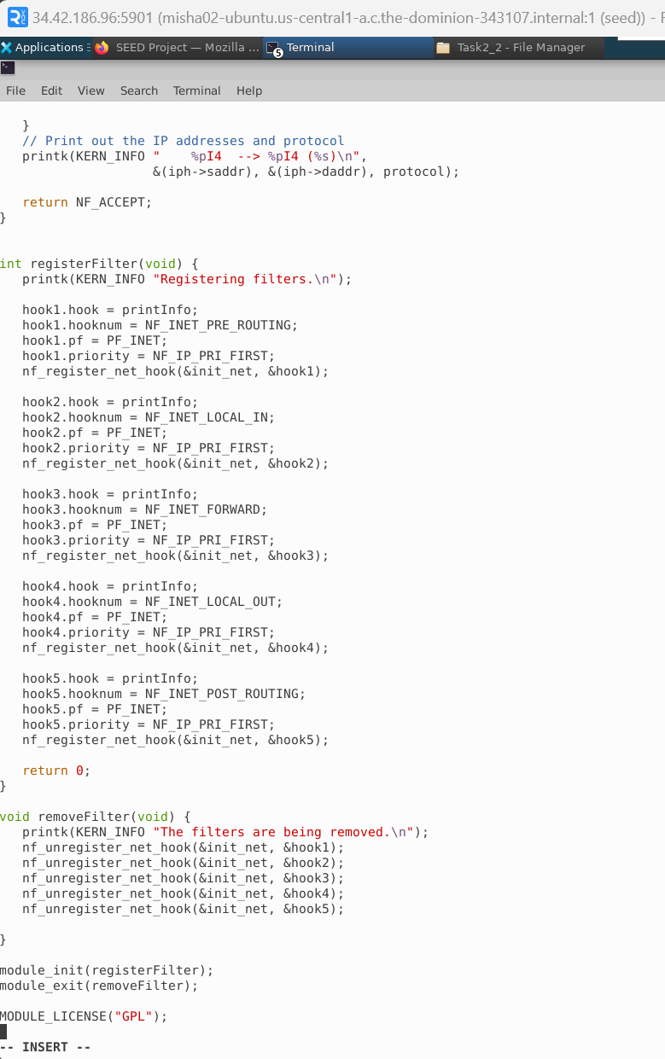

Now, compiling the module.

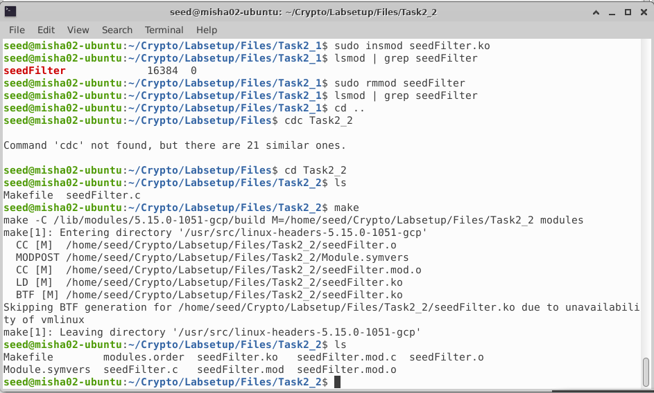

Now, installing the module and checking if it’s installed.

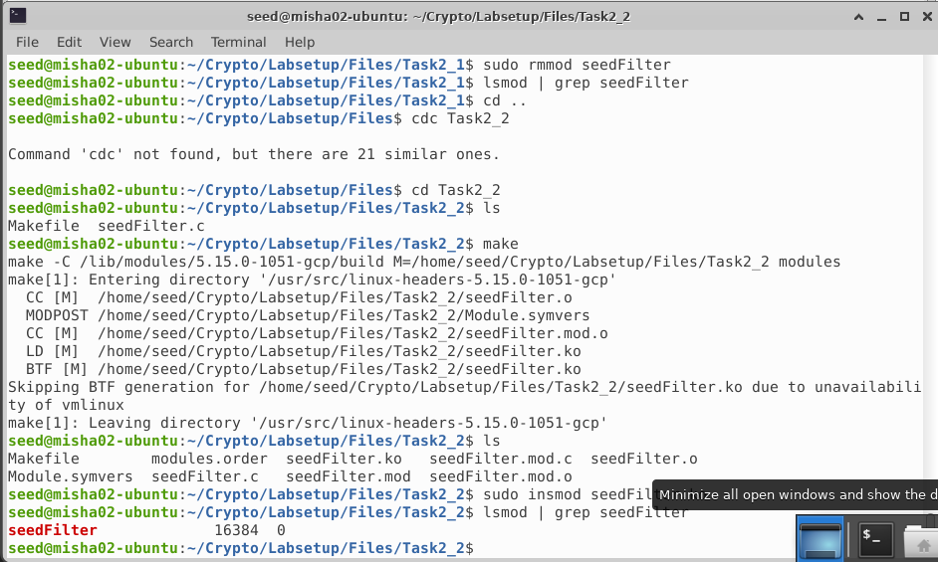

Post using the dig command, checking output of dmesg

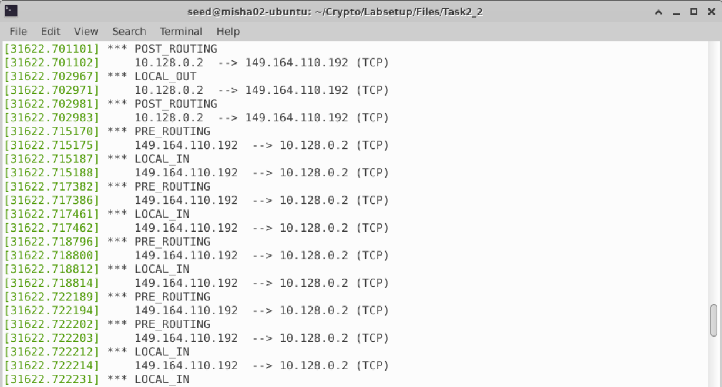

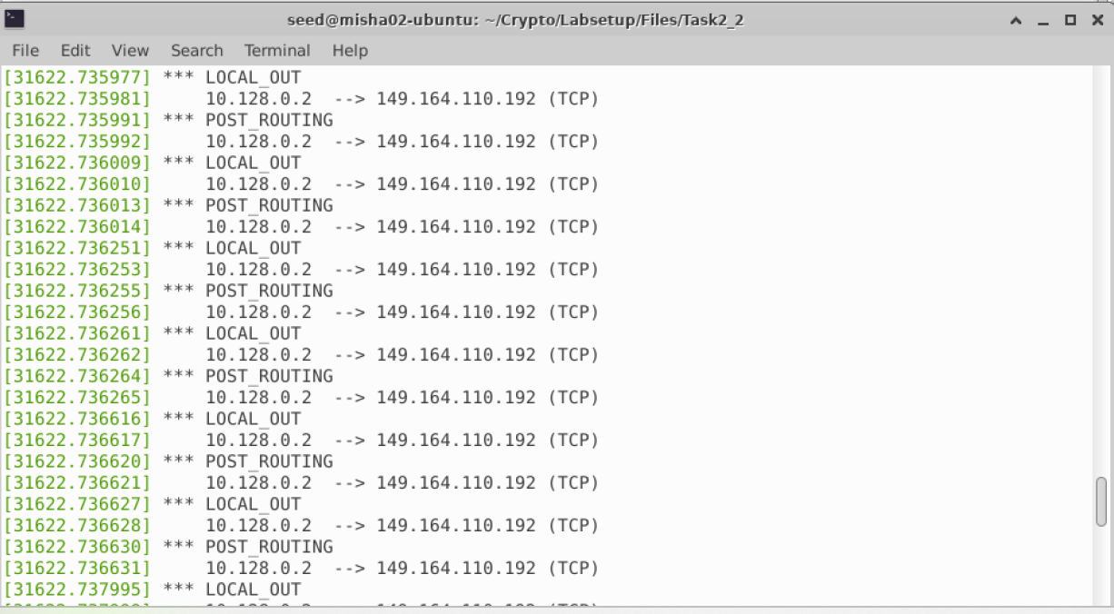

Now removing the module and checking if module is removed.

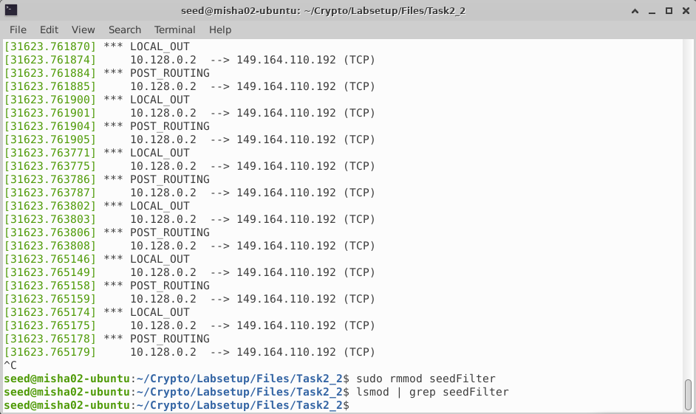

Based on the output we can conclude the following:

1. PreRouting is used at network stack entry before routing.
2. LocalIn is used for packets coming into the local system.
3. Forward is used to route out the packets for those that are not meant for local system.
4. LocalOut is used for packets going from local network to outside.
5. Post_Routing is used after routing decision.
6. The third part requires us to implement two more hooks to prevent other computers to ping VM and prevent other computers to telnet into VM. The code changes are as follows.

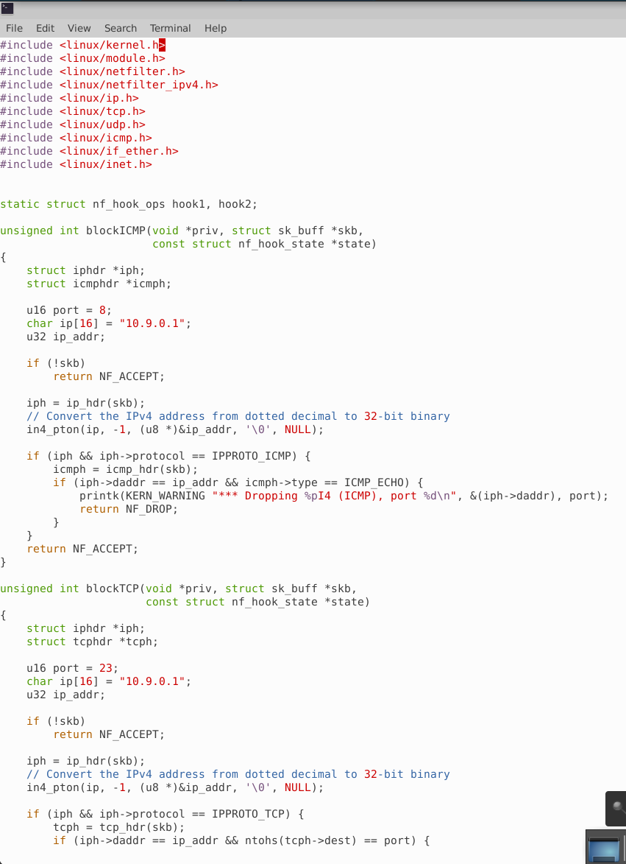

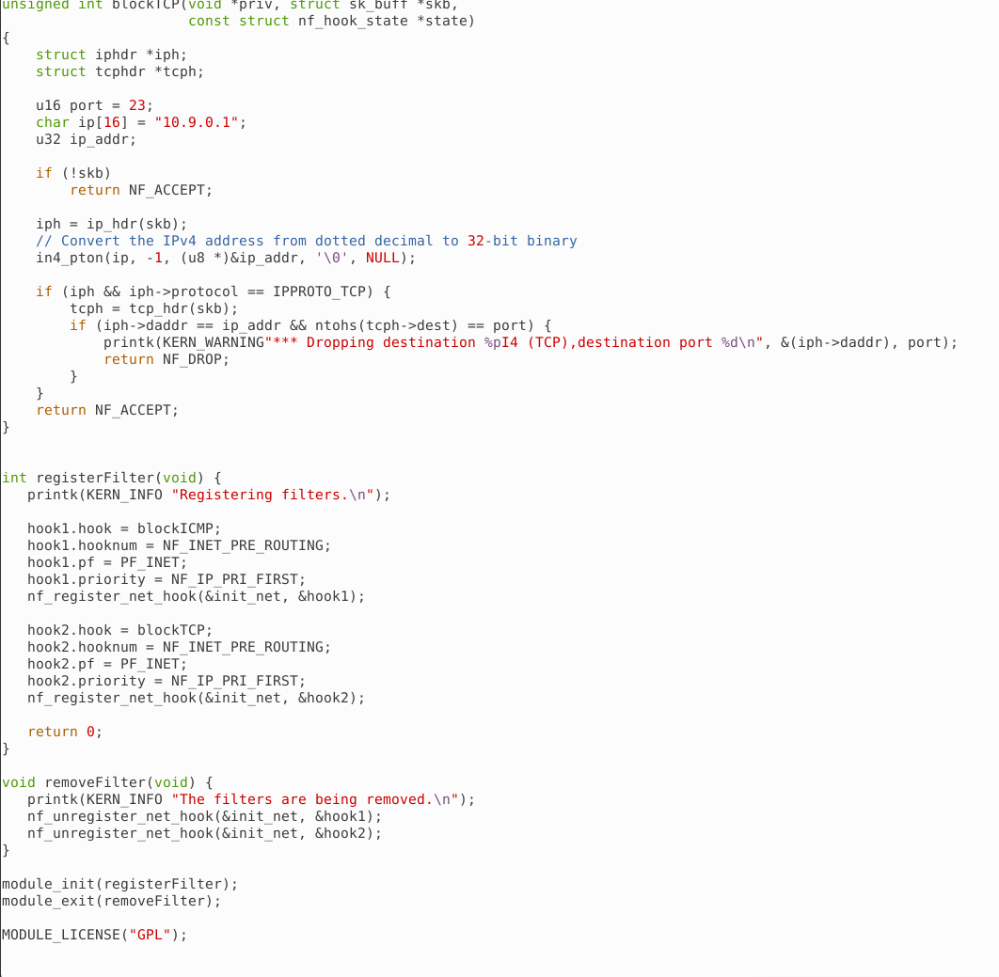

Now, compiling the module.

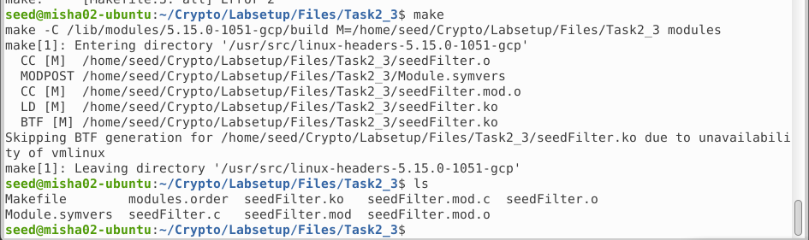

Now, installing the module and checking if installed.

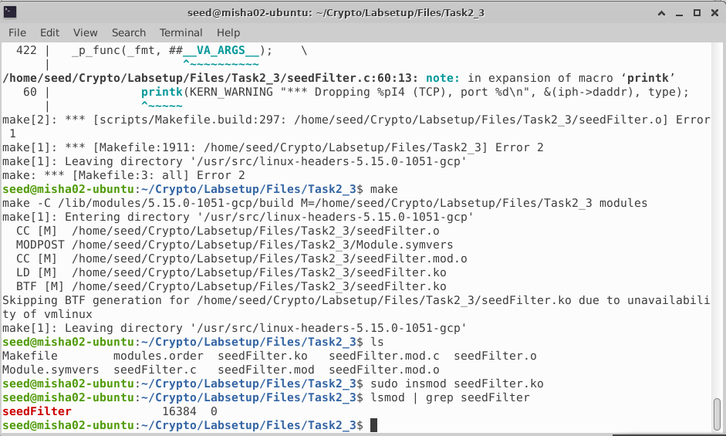

Now, checking if the ping is blocked.

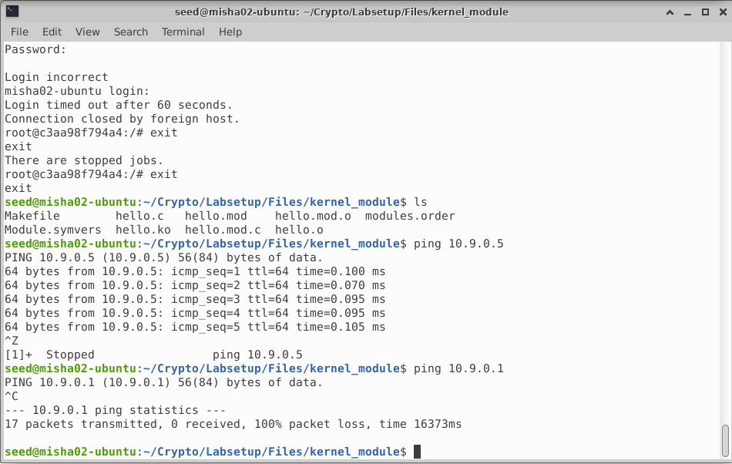

Now, checking if telnet is blocked. It is blocked as it got stuck.

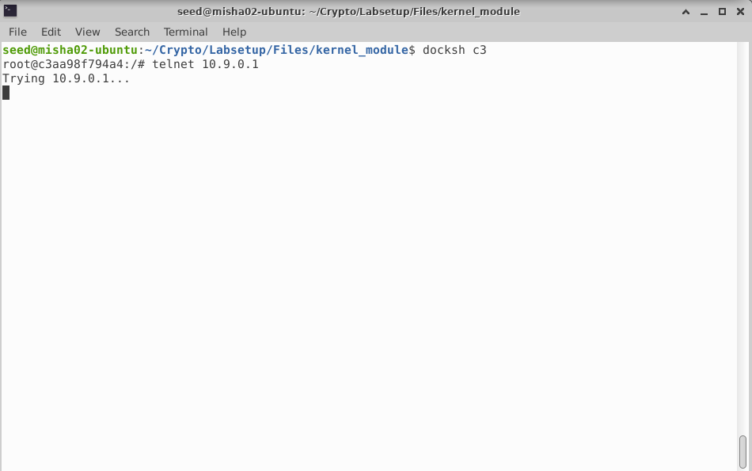

As we can see, the attack was successful.

* Task 2 (Experimenting with Stateless Firewall Rules): -
  + Task 2 A (Protecting the Router): -

For the second task, we need to implement provided iptables rules and discuss our observations. Firstly, we will docksh to router container.

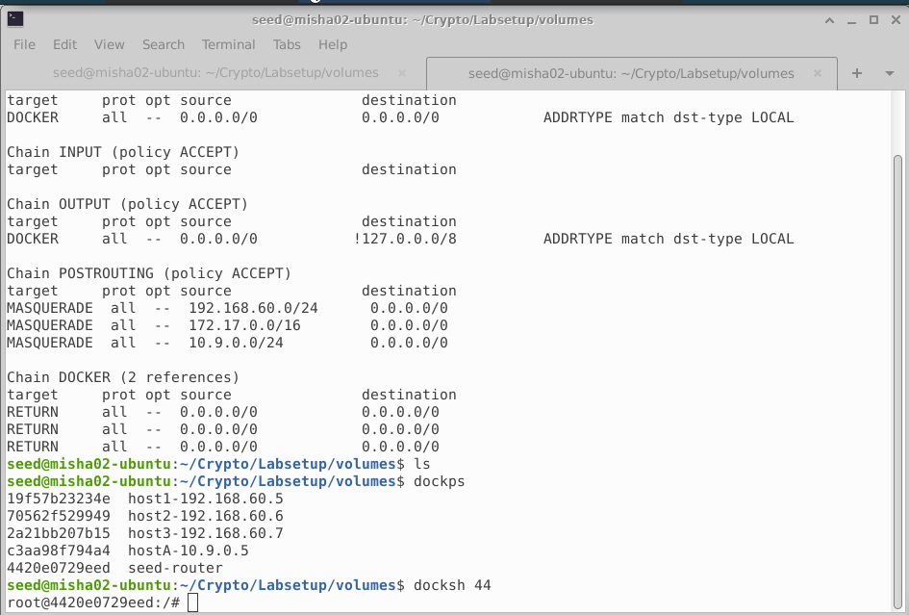

Now let’s see the iptables list.

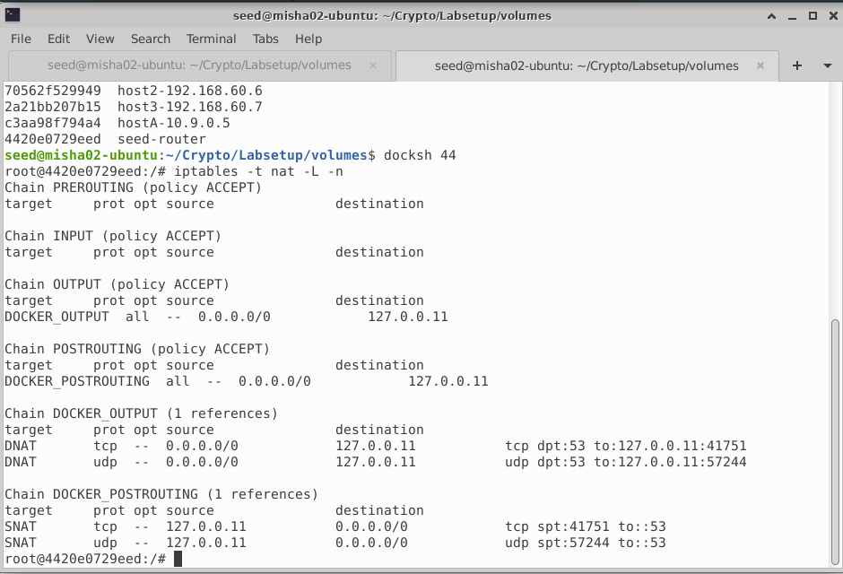

Now let’s run the iptables rules and check the updated table.

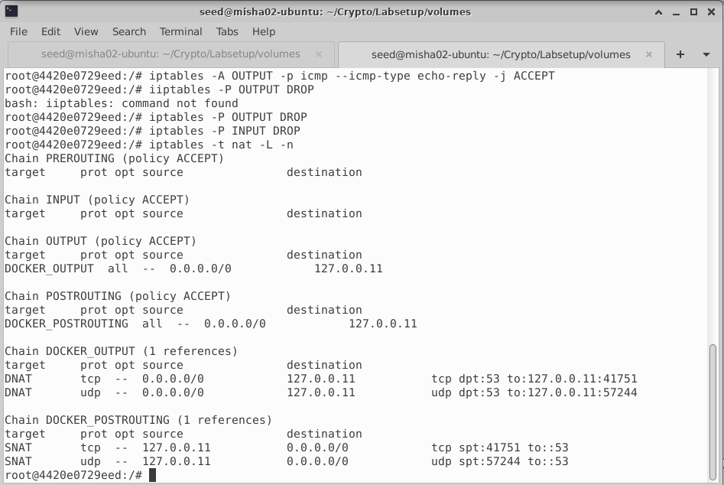

Now let's ping the router from 10.9.0.5

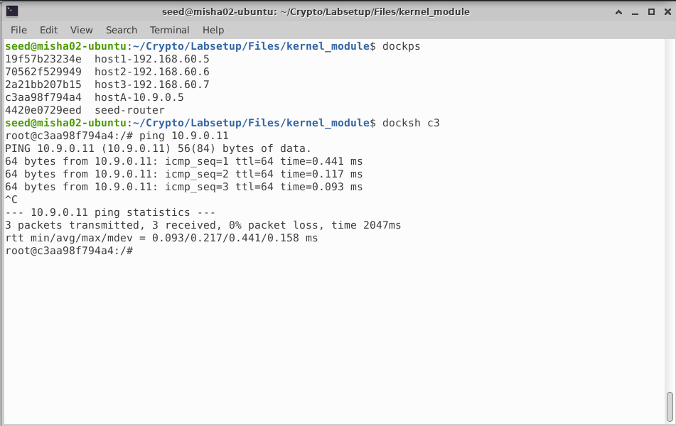

We can see that the ping was successful. Now let’s try performing telnet to router.

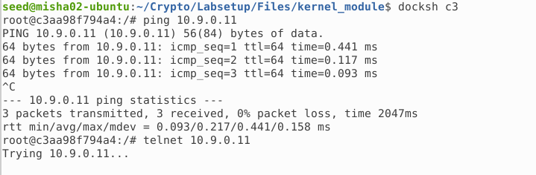

The telnet has failed.

* + Task 2 B (Protecting the Internal Network): -

In this task, we need to make sure that following rules are implemented: -

1. Outside hosts cannot ping internal hosts.
2. Outside hosts can ping the router.
3. Internal hosts can ping outside hosts.
4. All other packets between internal and external networks should be blocked.

Below is the list of rules applied.

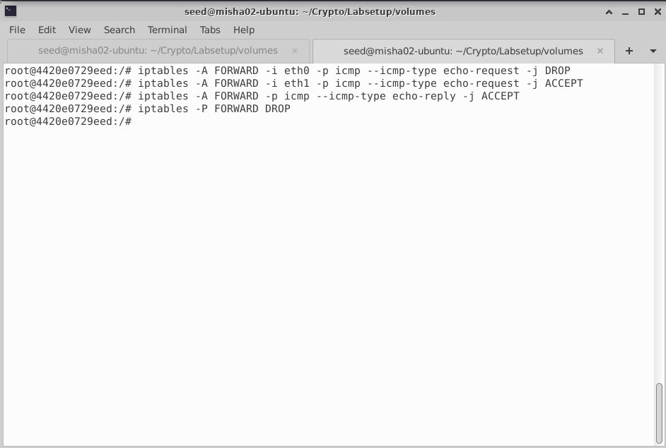

Outside pings are not coming to internal hosts.

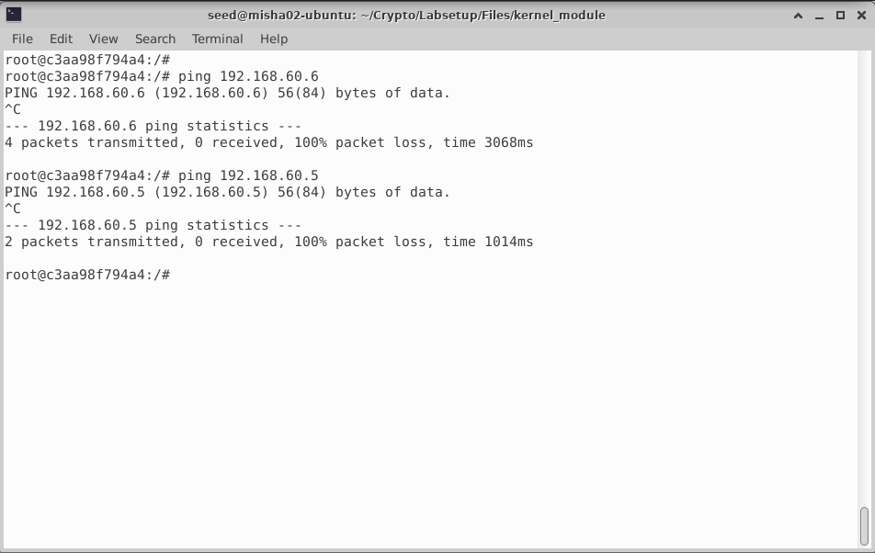

Outside pings reaching to router.

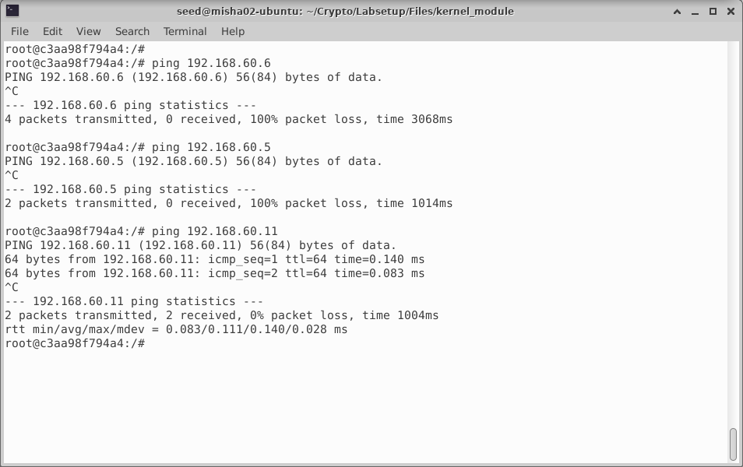

Internal hosts can ping outside hosts.

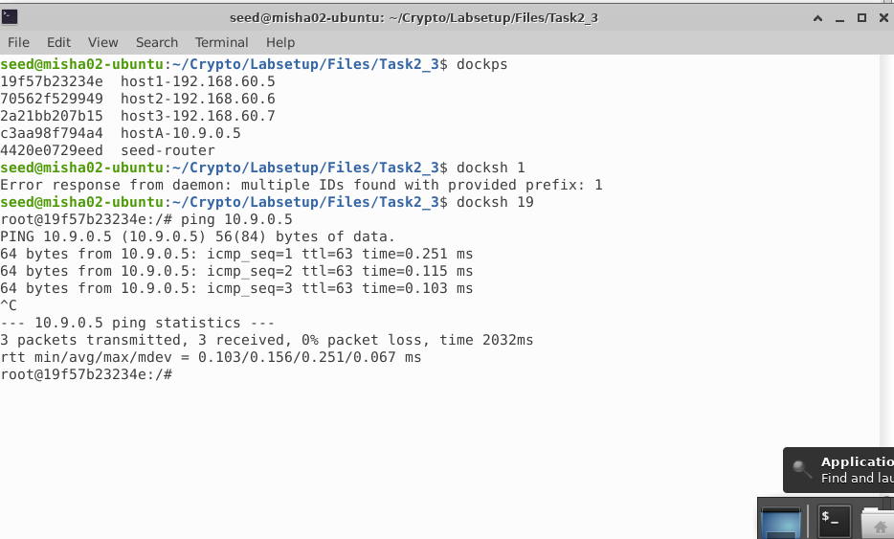

All other packets between internal and external hosts are blocked.

telnet from internal to external.

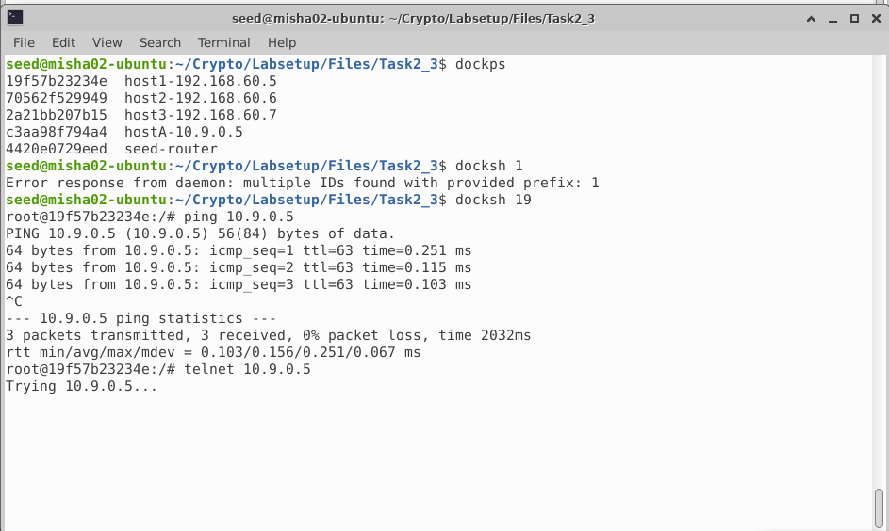

telnet from internal to external

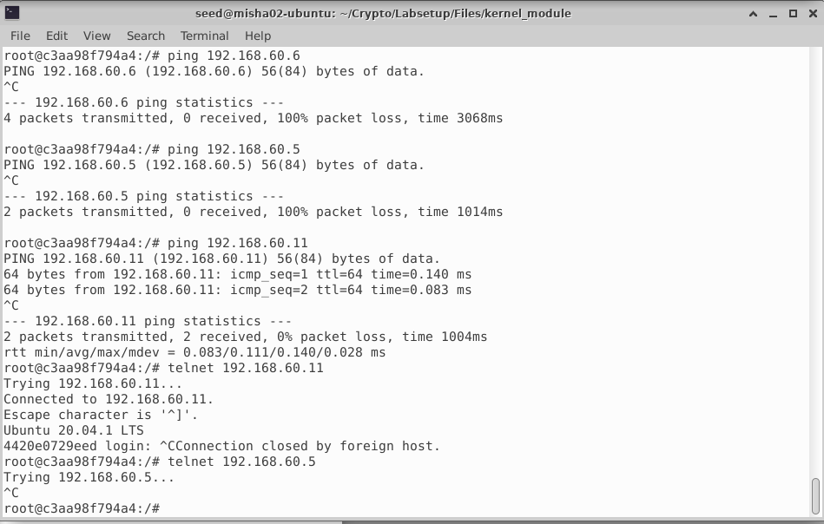

The implementation was successful.

* + Task 2 C (Protecting Internal Servers): -

In this task, we need to make sure that following rules are implemented: -

* + - * 1. All internal hosts run a telnet server. Outside host only access telnet on 192.168.60.5.
        2. Outside hosts cannot access other internal servers.
        3. Internal hosts can access all internal servers.
        4. Internal hosts cannot access external servers.
        5. Connection tracking mechanism is not allowed.

Below is the list of rules applied.

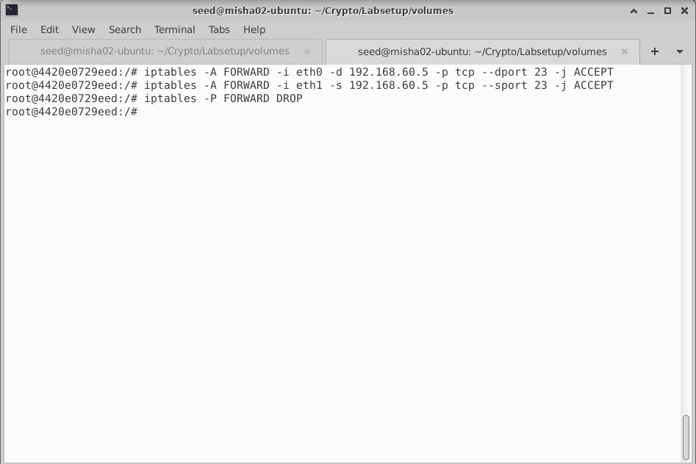

Outside hosts able to access telnet on 192.168.60.5.

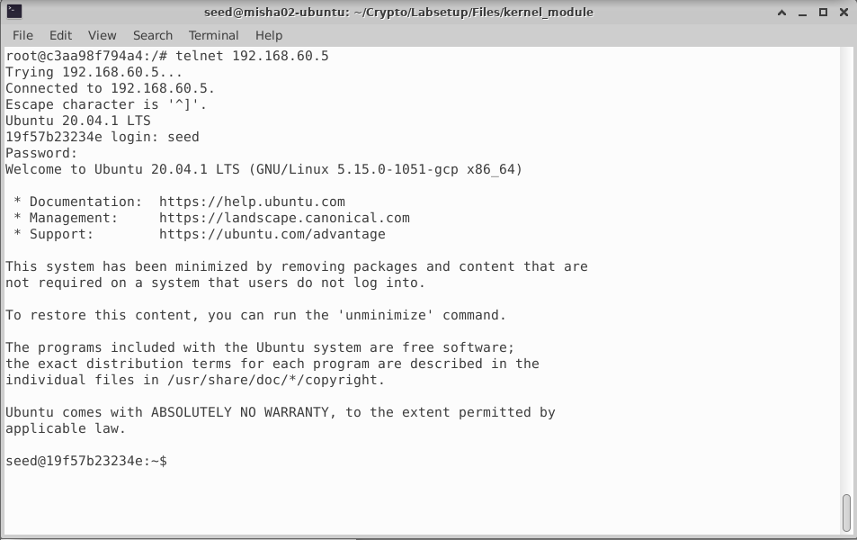

Outside hosts unable to access other internal servers.

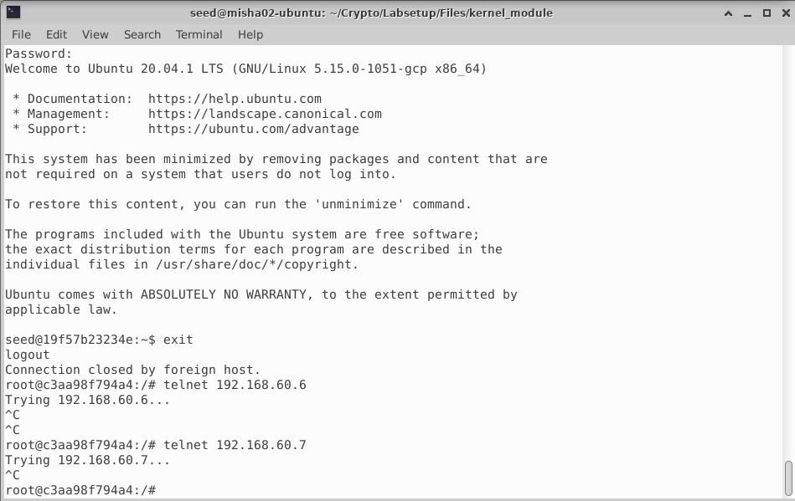

Internal hosts able to access other internal servers.

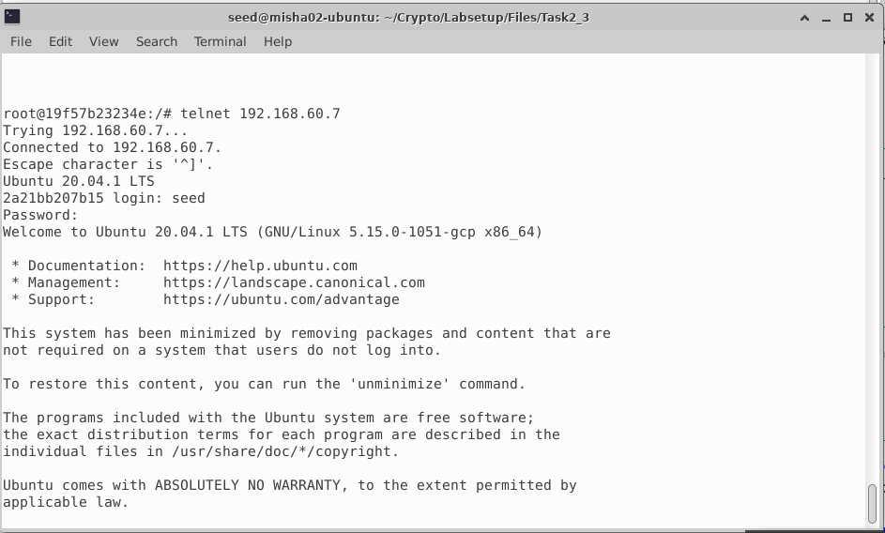

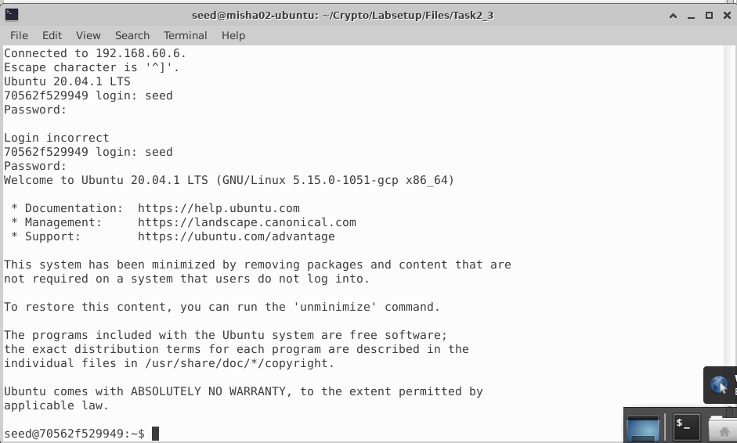

Internal hosts cannot access external servers.

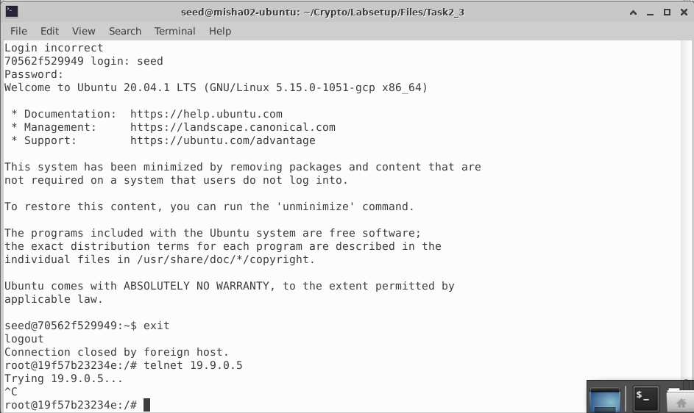

* Task 3 (Connection Tracking and Stateful Firewall): -
  + Task 3 A (Experiment with the Connection Tracking): -

a. ICMP Experiment: -

Before pinging value of conntrack = 0.

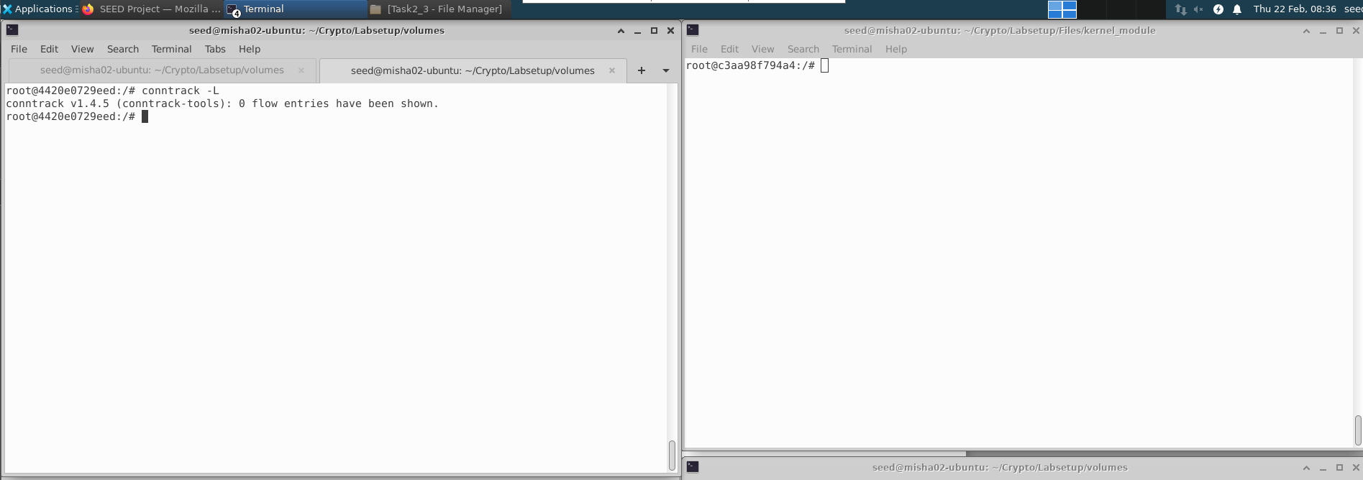

While pinging value of conntrack = 1.

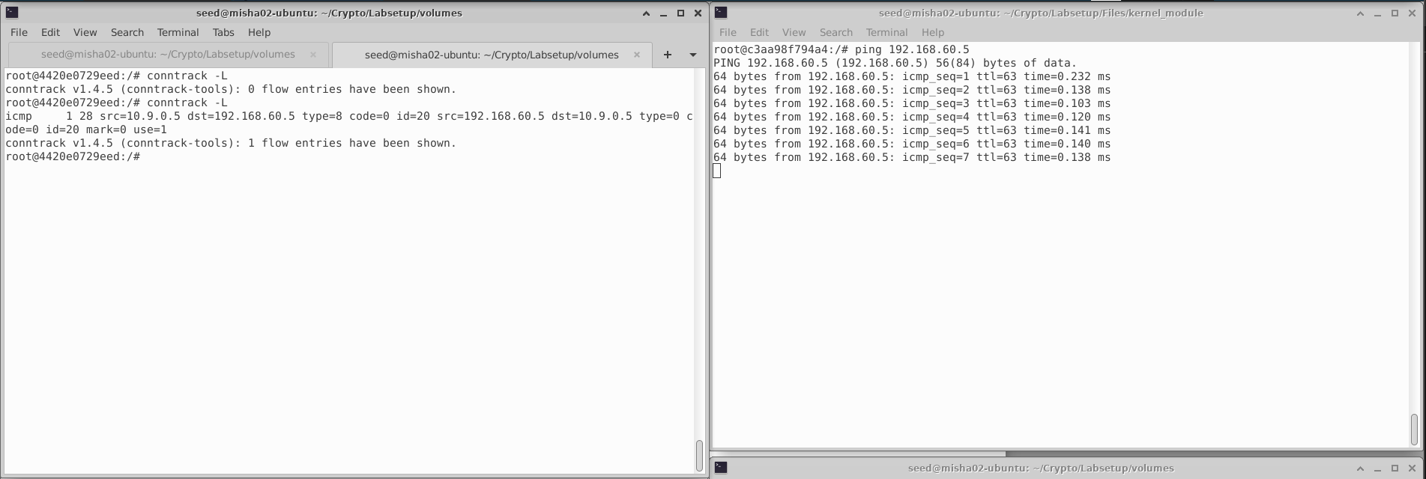

After pinging is ended, value of conntrack = 1 momentarilly.

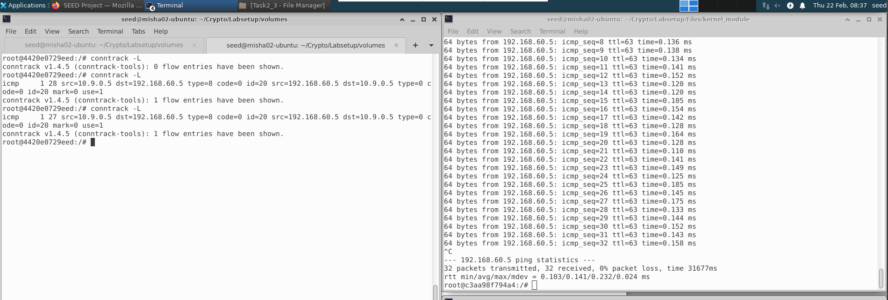

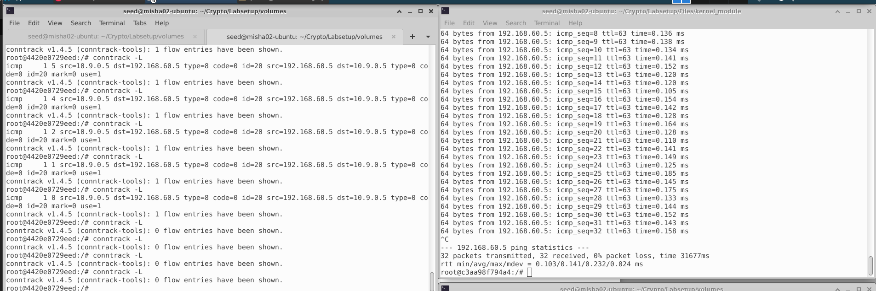

b. UDP Experiment: -

Before nc, value of conntrack = 0.

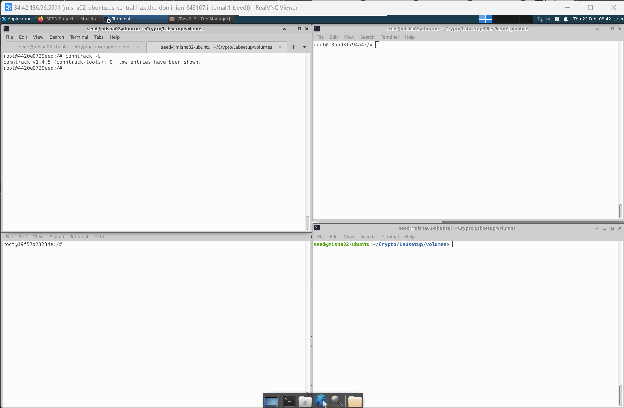

Starting a netcat UDP server, value of conntrack = 0

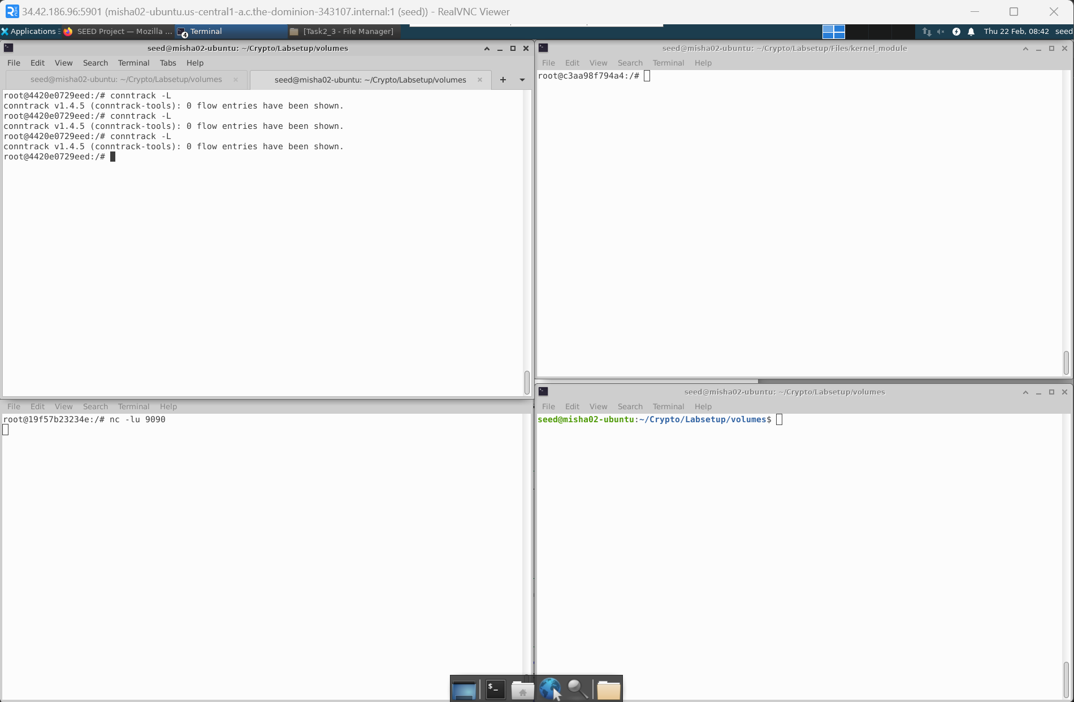

Sending out UDP packets from external, conntrack = 1 momentarily and then becomes 0

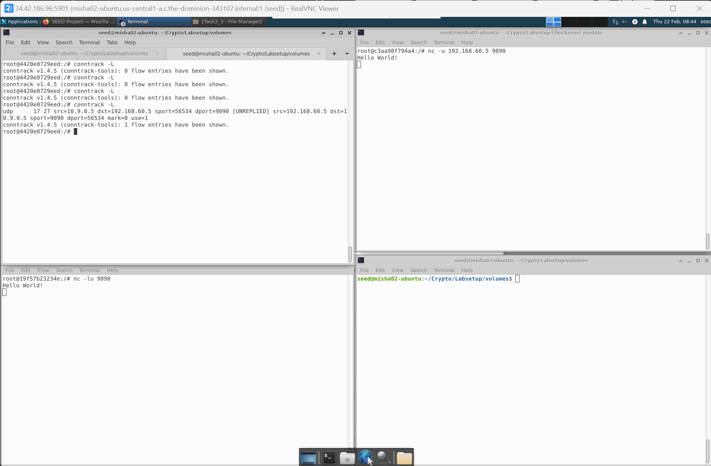

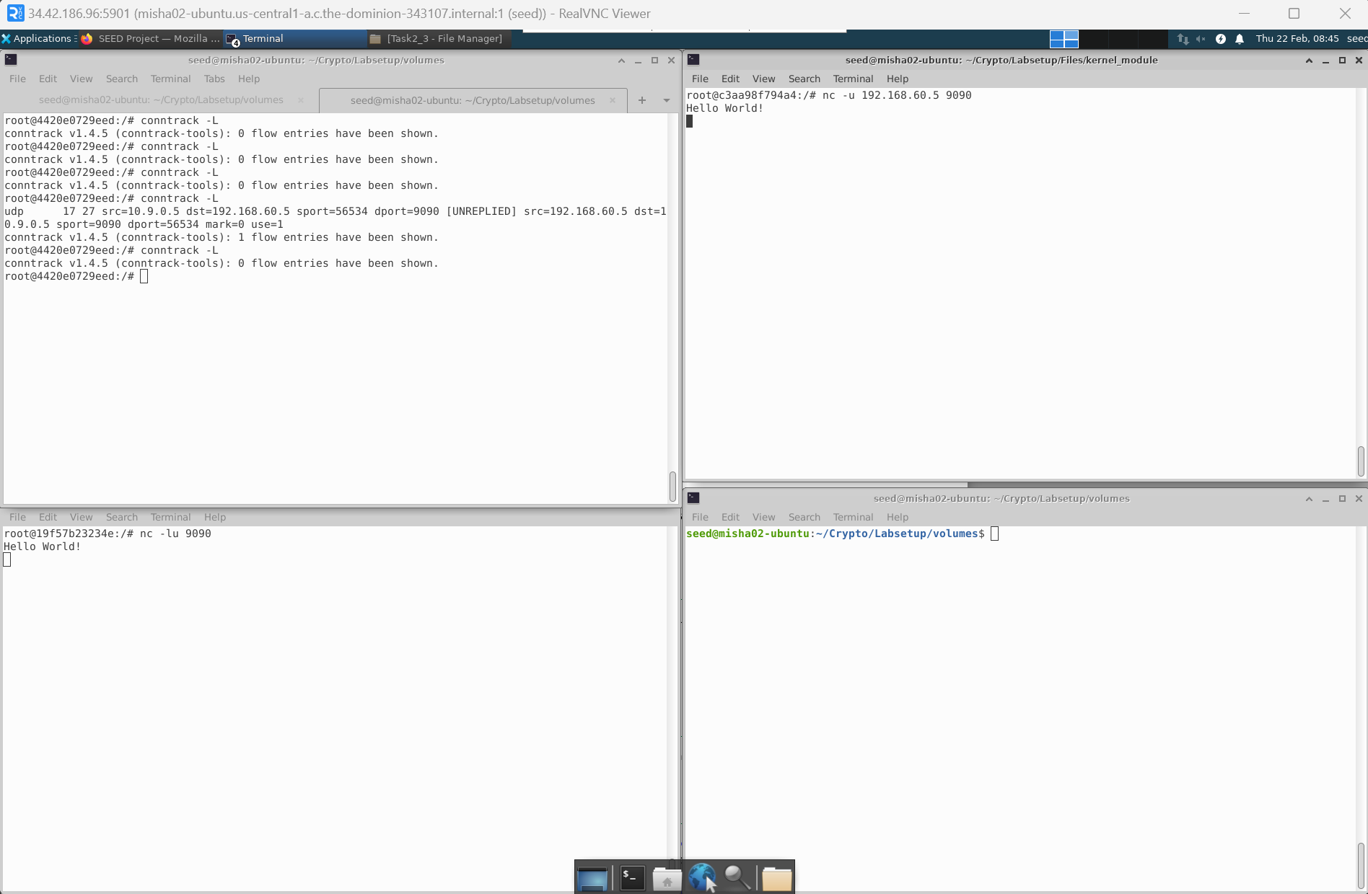

1. TCP Experiment: -

Before nc, value of conntrack =0

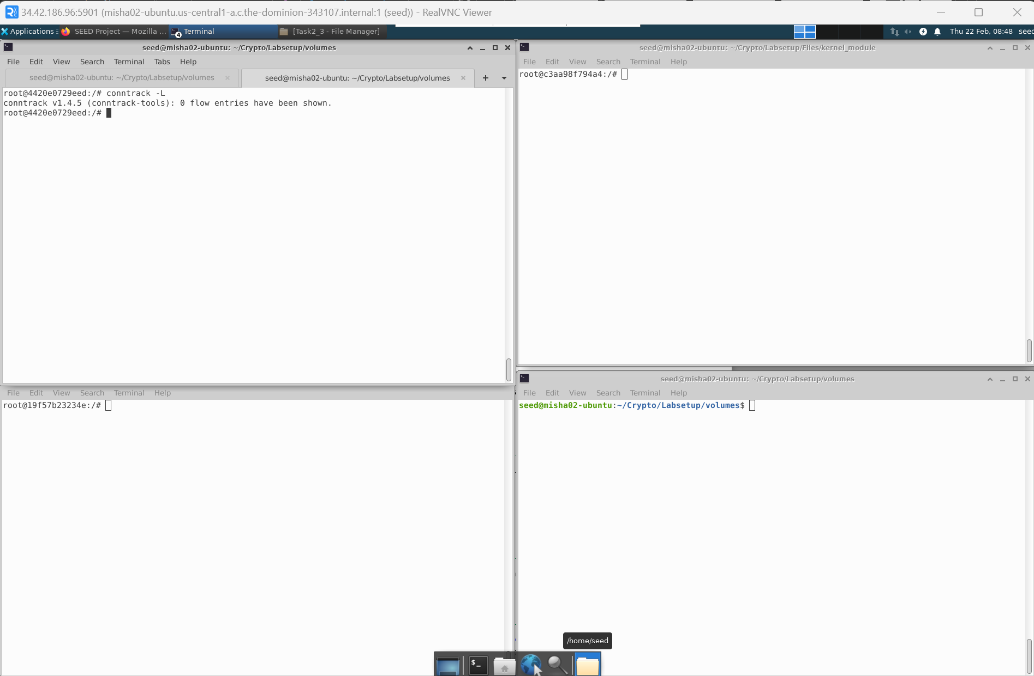

After nc, value of conntrack = 1 momentarily

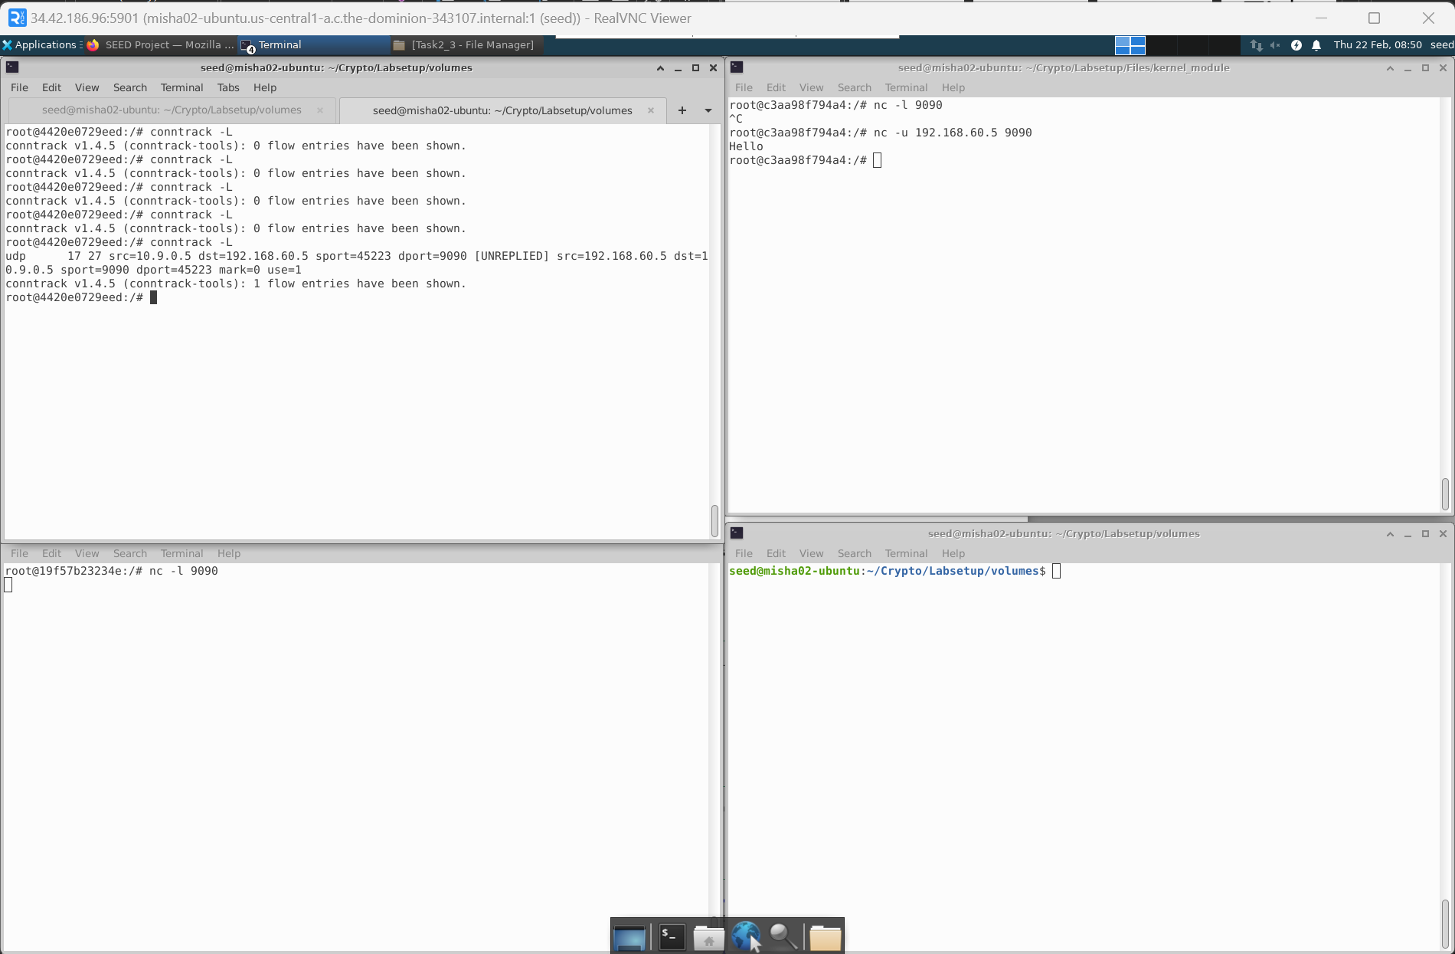

A common observation is that the conntrack value remains in the range from 30s to 1 min.

* + Task 3 B (Setting Up a Stateful Firewall): -

The task is very much similar to 2C, the only difference is that we are allowing internal hosts to visit any external server.

Below is the list of rules applied.

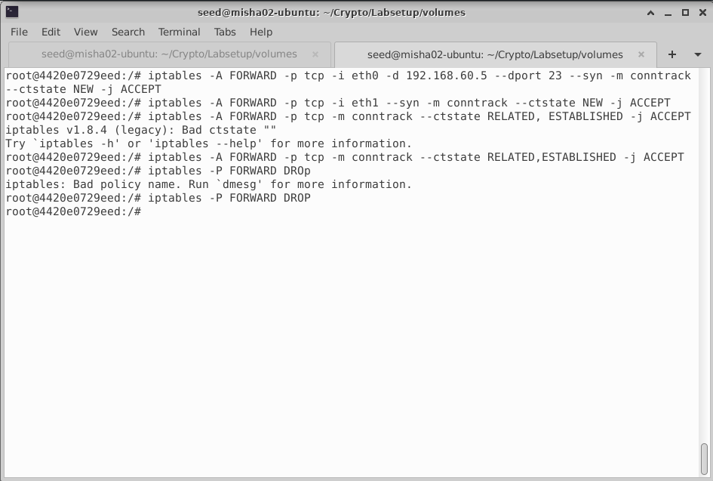

Outside hosts can access to 192.168.60.5

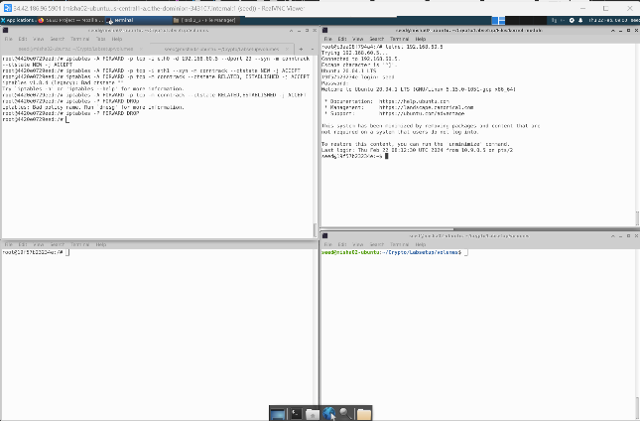

Outside hosts cannot access other internal servers

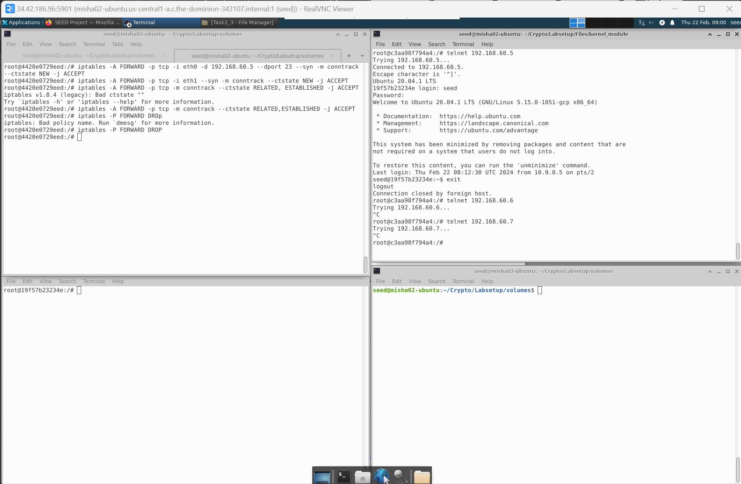

Internal hosts can access internal servers.

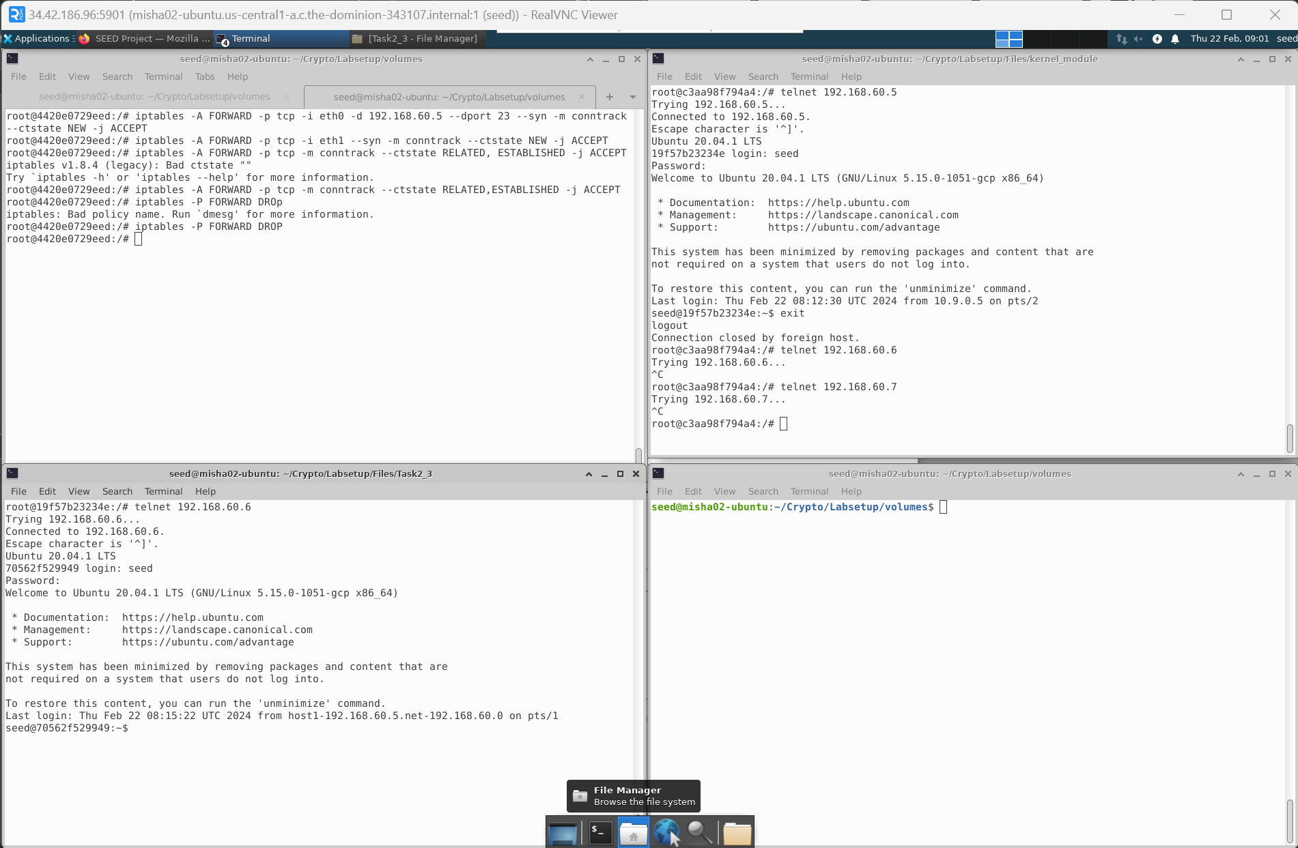

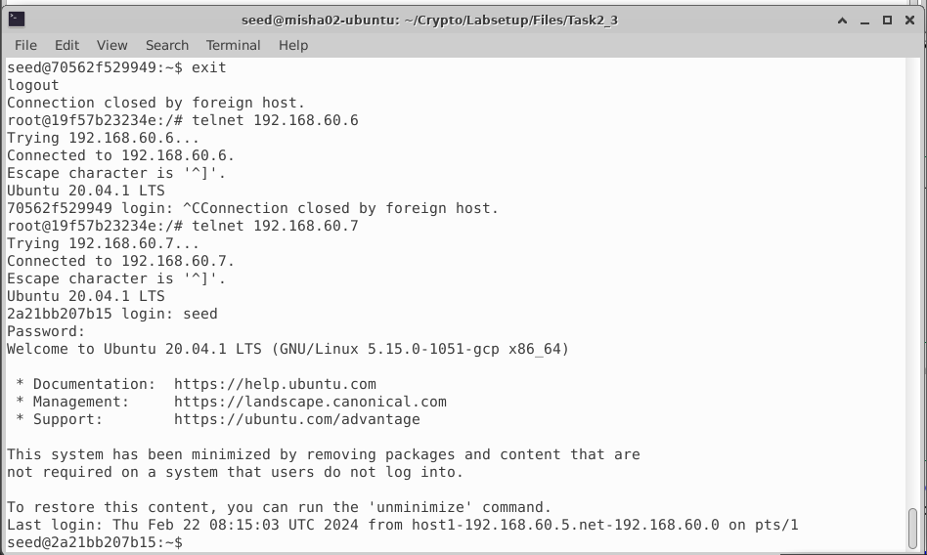

Internal hosts can access external servers.

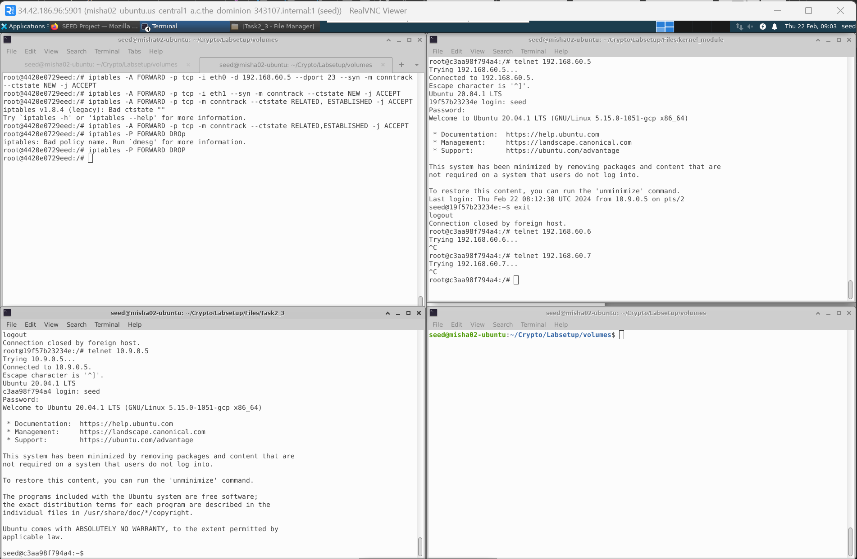

Earlier, the implementation was without connection tracking and now that is implemented. As we are tracking the state of connections, it’s a stateful firewall for current implementation.

* Task 4 (Limiting Network): -

In this task, we will be limiting the number of packets that can pass through the firewall.

Without second rule: -

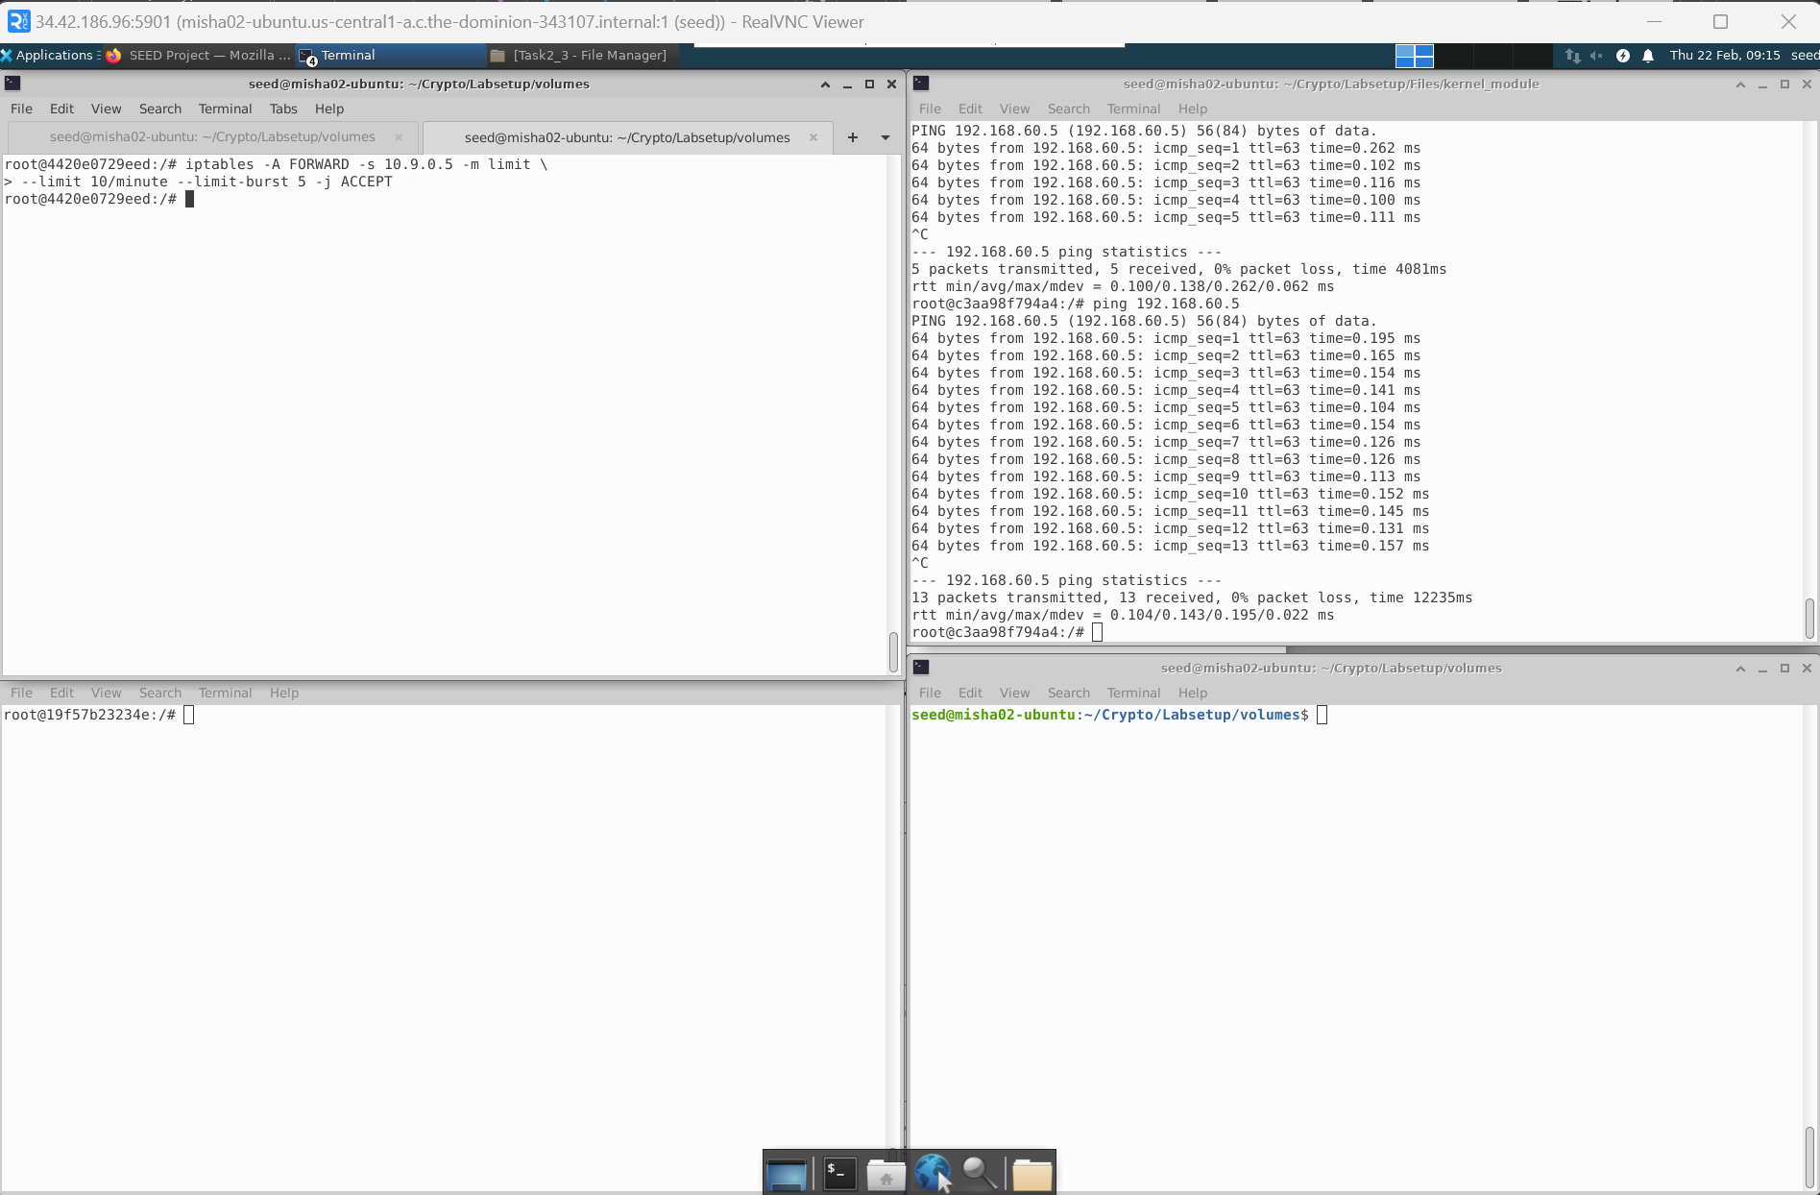

Without the second rule, the limiter is not working.

With second rule: -

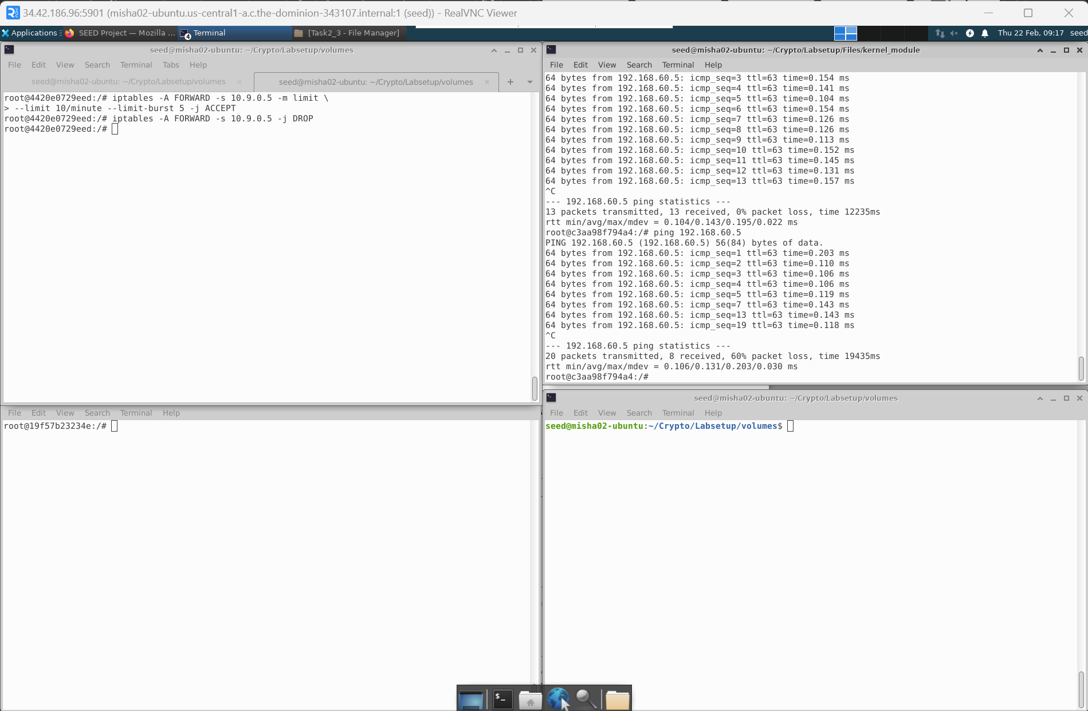

As we can see that due to the second rule, we are successfully able to limit the pings. Hence, second rule is required.

* Task 5 (Load Balancing): -
  + Using the nth mode (round-robin)

In this task we need to balance the load among 3 . Rules are as follows.

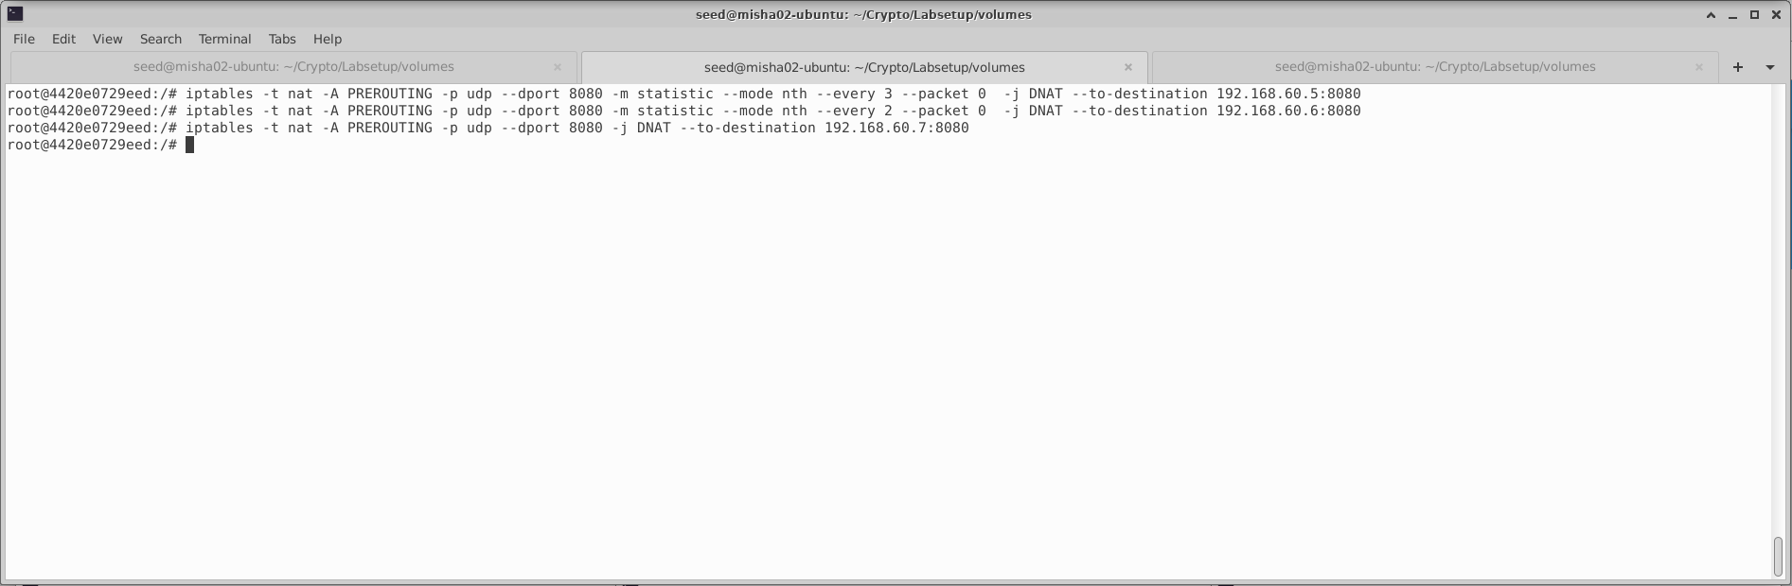

Let’s pass values from external to internal servers.

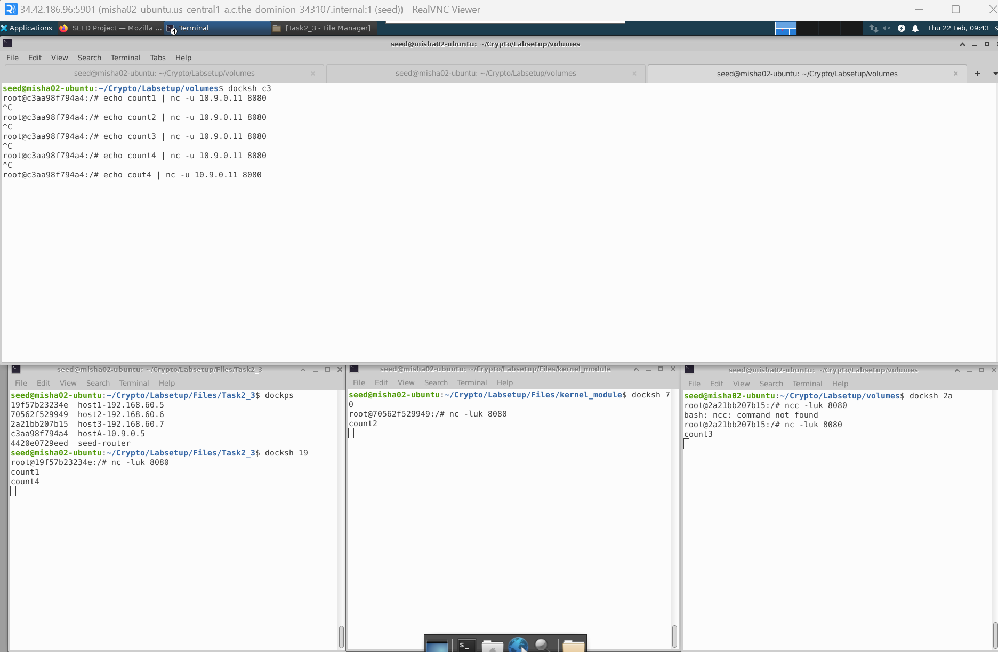

As we can see that the implementation was successful.

* + Using the random mode

The script is as follows:-

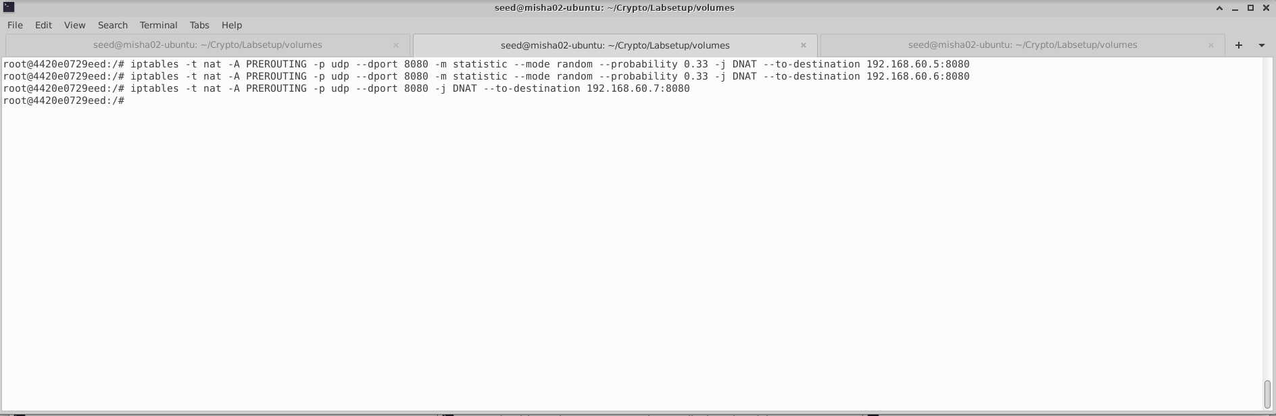

Post running the echo output is as follows.

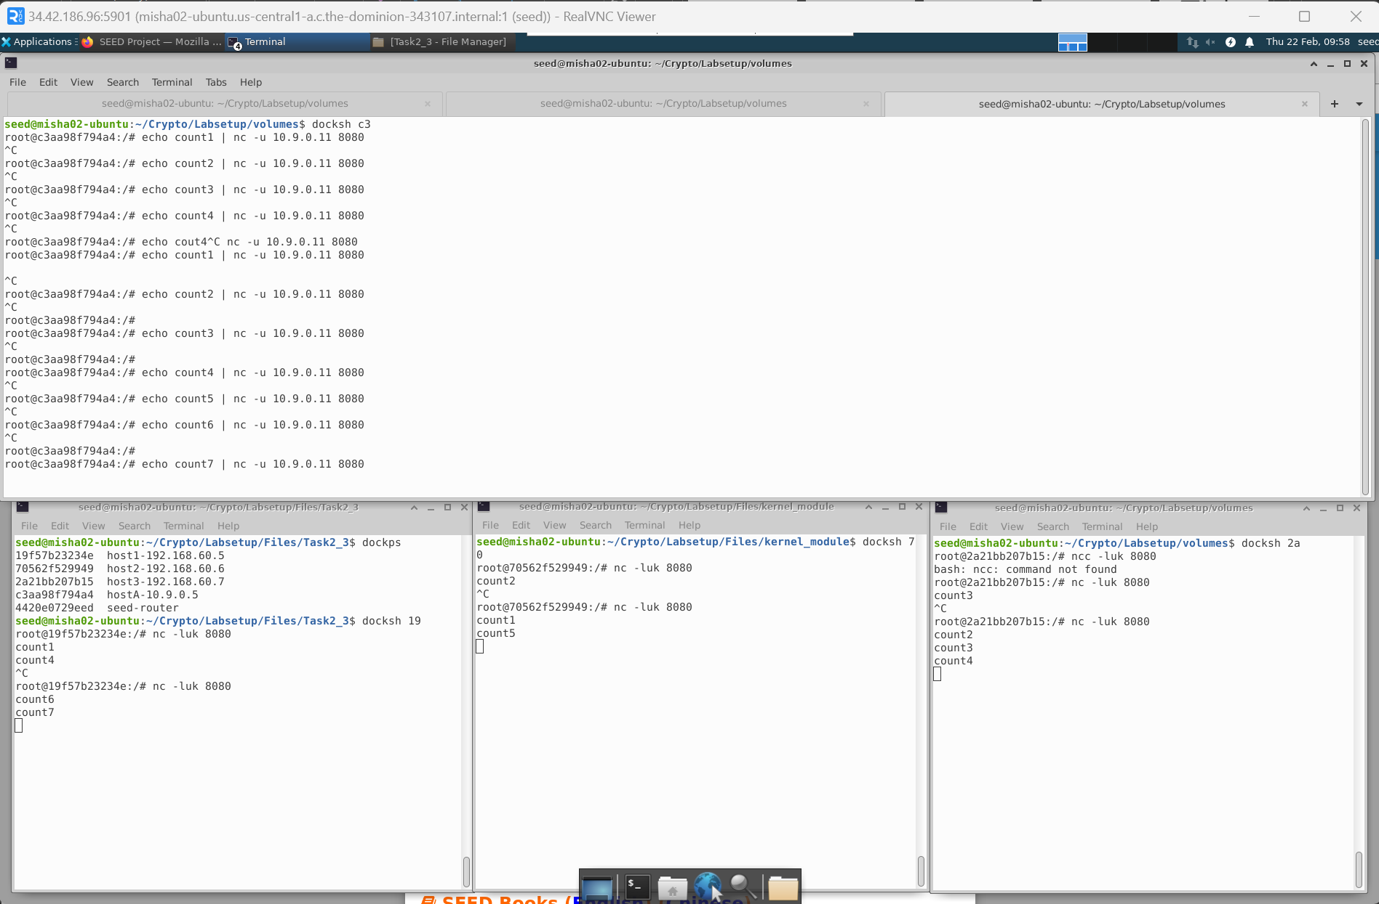

The probability Is set to 0.33 purposefully to give all three similar chance to pickup.

* Conclusion: -

The overall experience was exciting. I will be going deeper into the subject and try to discover new ways to handle how we had practiced in lab. Having a base knowledge of how Firewalls work, I will like to do a deep dive in this subject to find out more about how to protect the target machines from attacks that occur in a simple manner.